
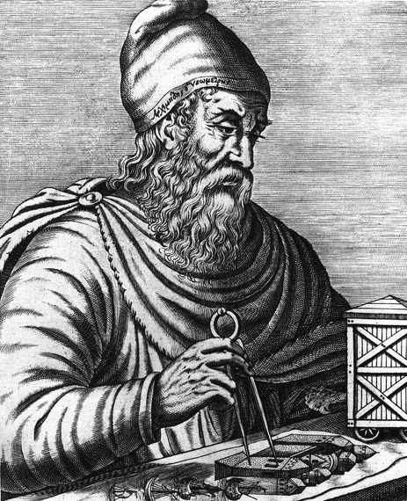


He is the most famous mathematician and inventor of ancient Greece. Archimedes is especially important for his discovery of the relation between the surface and volume of a sphere and its circumscribing cylinder. He is known for his formulation of a hydrostatic principle (known as Archimedes’ principle) and a device for raising water, still used in developing countries, known as the Archimedes screw.
ARCHIMEDES
287 - 212 B.C.

