
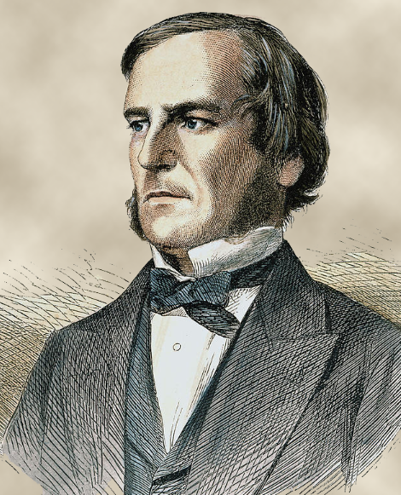


George Boole (1815–1864) was an English mathematician and a founder of the algebraic tradition in logic. He worked as a schoolmaster in England and from 1849 until his death as professor of mathematics at Queen's University, Cork, Ireland. He revolutionized logic by applying methods from the then-emerging field of symbolic algebra to logic. Where traditional (Aristotelian) logic relied on cataloging the valid syllogisms of various simple forms, Boole's method provided general algorithms in an algebraic language which applied to an infinite variety of arguments of arbitrary complexity.
George Boole
(1815-1864)

