
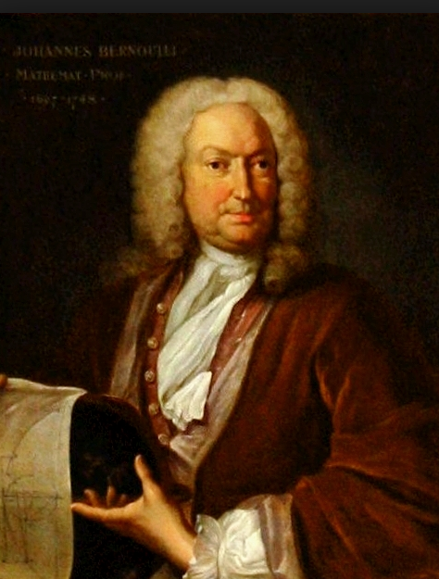
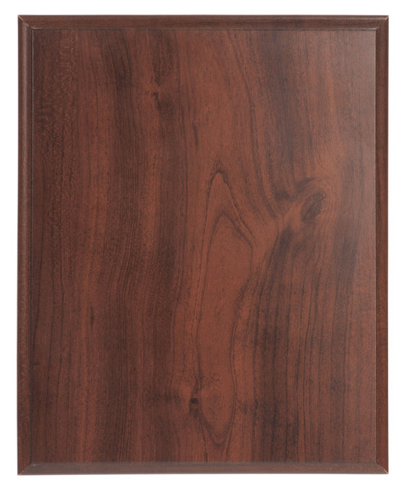
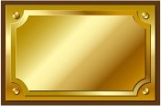
He investigated the then new mathematical calculus, which he applied to the measurement of curves, to differential equations, and to mechanical problems. The son of a pharmacist, Johann studied medicine and obtained his doctor’s degree in Basel in 1694, with a thesis on muscular contraction. However, he turned to mathematics despite his father’s opposition. In 1691–92 he wrote two texts, not published until later, on differential and integral calculus. In 1692 he taught calculus to the mathematician Guillaume-François-Antoine de L’Hospital, who agreed to pay him for mathematical discoveries. From 1695 to 1705 he taught mathematics at Groningen, Neth., and, on the death of his elder brother, Jakob, assumed a professorship at Basel.

Read more: http://blogs.smithsonianmag.com/science/2011/10/five-historic-female-mathematicians-you-should-know/#ixzz2hGPhtEGB
Follow us: @SmithsonianMag on Twitter

Read more: http://blogs.smithsonianmag.com/science/2011/10/five-historic-female-mathematicians-you-should-know/#ixzz2hGNMgdc9
Follow us: @SmithsonianMag on Twitter

1667-1748
Johann Bernoulli

