
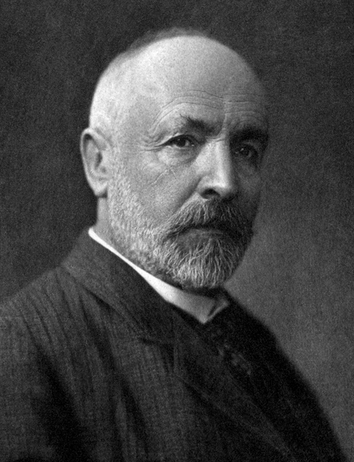


He revolutionized the foundation of mathematics with set theory. Set theory is now considered so fundamental that it seems to border on the obvious but at its introduction it was controversial and revolutionary. The controversial element centered around the problem of whether infinity was a potentiality or could be achieved. Before Cantor it was generally felt that infinity as an actuality did not make sense; one could only speak of a variable increasing without bound as that variable going to infinity. That is to say, it was felt that n → ∞ makes sense but n = ∞ does not. Cantor not only found a way to make sense out an actual, as opposed to a potential, infinity but showed that there are different orders of infinity. This was a shock to people's intuition.
Georg Cantor
(1845-1918)

