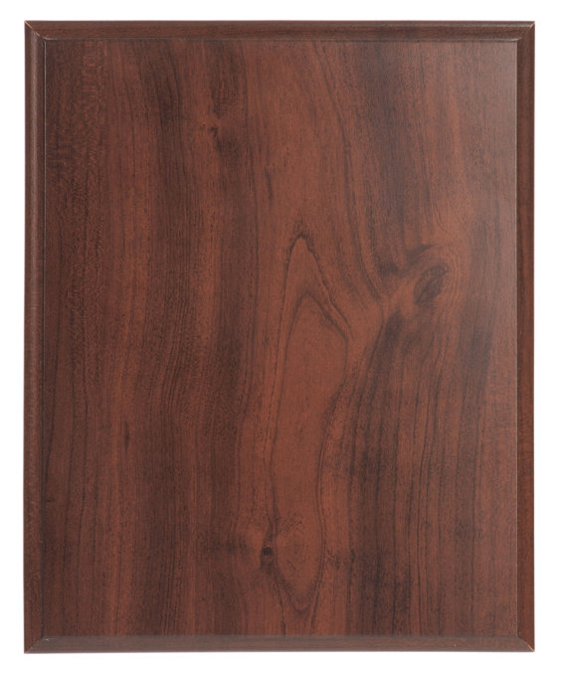
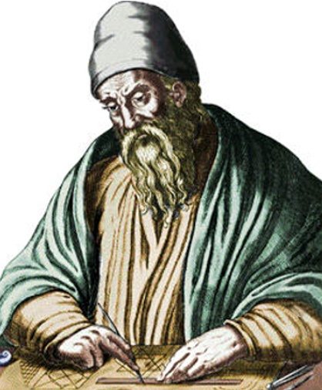


circa 300 B.C.
EUCLID
He was the most prominent mathematician of Greco-Roman antiquity, best known for his Treatise on Geometry, the Elements. Of Euclid’s life nothing is known except what the Greek philosopher Proclus (c. ad 410–485) reports in his “summary” of famous Greek mathematicians. According to him, Euclid taught at Alexandria in the time of Ptolemy I Soter, who reigned over Egypt from 323 to 285 BC. Proclus supported his date for Euclid by writing “Ptolemy once asked Euclid if there was not a shorter road to geometry than through the Elements, and Euclid replied that there was no royal road to geometry.” Today few historians challenge the consensus that Euclid was older than Archimedes (c. 290/280–212/211 BC).

