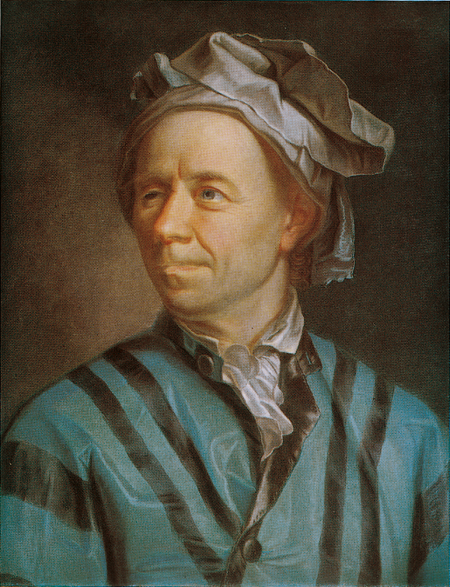

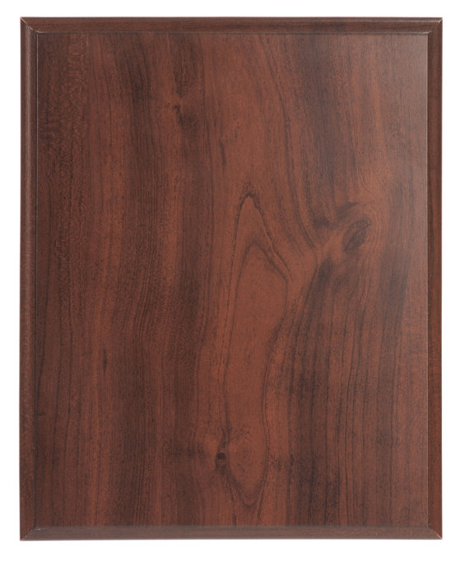

(1707-1783)
Leonhard Euler
He was arguably the greatest mathematician of the eighteenth century (His closest competitor for that title is Lagrange) and one of the most prolific of all time; his publication list of 886 papers and books may be exceeded only by Paul Erdös. Euler's complete works fill about 90 volumes. Remarkably, much of this output dates from the last two decades of his life, when he was totally blind..

