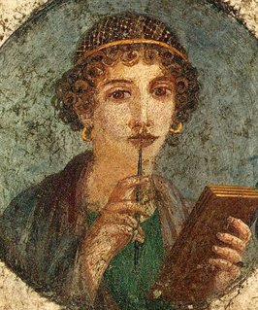



Hypatia
No one can know who was the first female mathematician, but Hypatia was certainly one of the earliest. She was the daughter of Theon, the last known member of the famed library of Alexandria, and followed his footsteps in the study of math and astronomy. She collaborated with her father on commentaries of classical mathematical works, translating them and incorporating explanatory notes, as well as creating commentaries of her own and teaching a succession of students from her home. Hypatia was also a philosopher, a follower of Neoplatonism, a belief system in which everything emanates from the One, and crowds listened to her public lectures about Plato and Aristotle. Her popularity was her downfall, however. She became a convenient scapegoat in a political battle between her friend Orestes, the governor of Alexandria, and the city’s archbishop, Cyril, and was killed by a mob of Christian zealots.
Read more: http://blogs.smithsonianmag.com/science/2011/10/five-historic-female-mathematicians-you-should-know/#ixzz2hGNMgdc9
Follow us: @SmithsonianMag on Twitter

360 – 415 A.D.

