

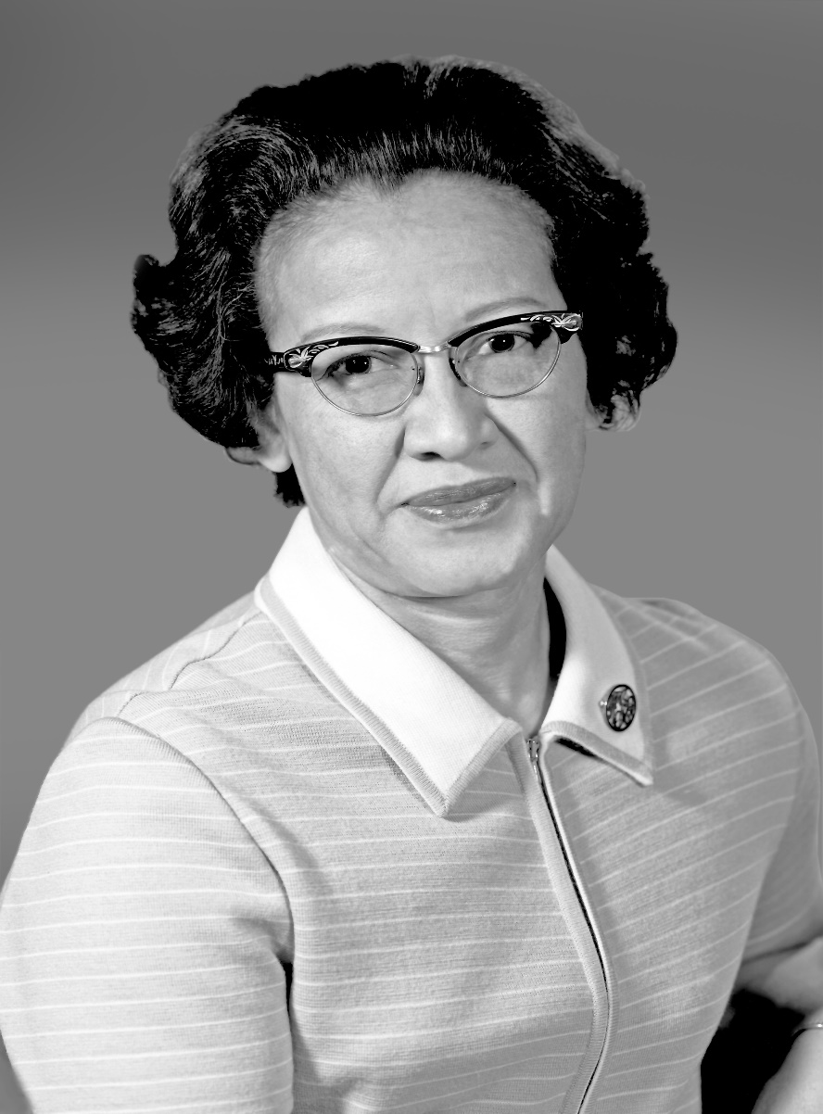
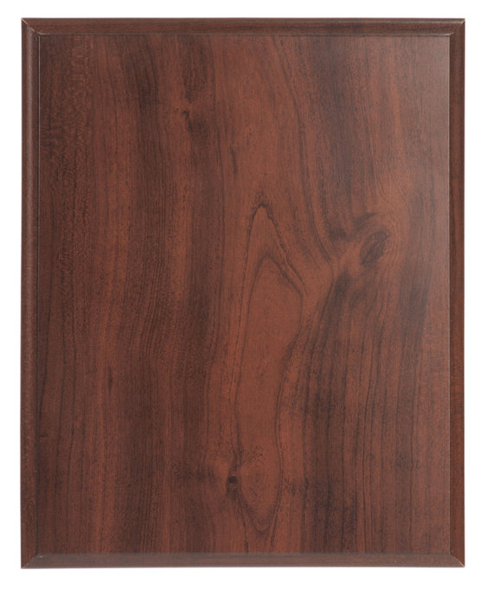
1918–2020 A.D.
Katherine Johnson
Katherine Johnson was an American mathematician who calculated and analyzed the flight paths of many spacecraft during her more than three decades with the U.S. space program. Her work helped send astronauts to the Moon. She graduated from college at the age of 18. She began working in aeronautics as a "computer" in 1952, and after the formation of NASA, she performed the calculations that sent astronauts into orbit in the early 1960s and to the moon in 1969. Johnson was honored with the Presidential Medal of Freedom in 2015 and saw her story brought to light through a book and a feature film the following year. She passed away on February 24, 2020, at the age of 101.

