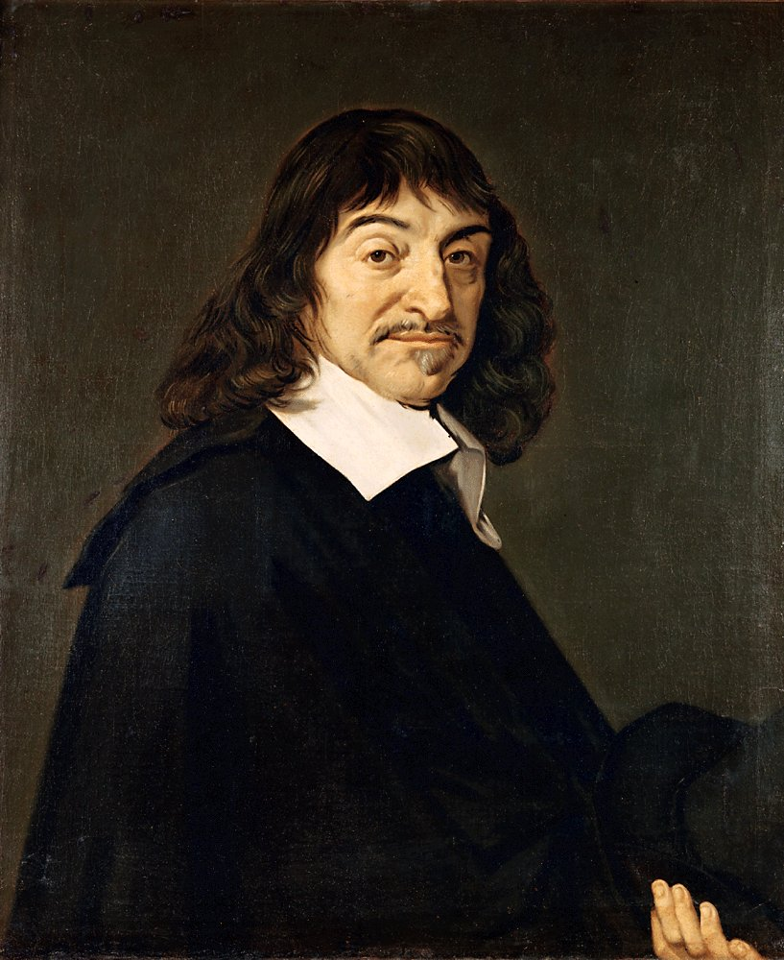



(1596-1650)
He was a creative mathematician, an important scientific thinker, and an original metaphysician. During the course of his life, he was a mathematician first, a natural scientist or “natural philosopher” second, and a metaphysician third. In mathematics, he developed the techniques that made possible algebraic (or “analytic”) geometry. In natural philosophy, he can be credited with several specific achievements: co-framer of the sine law of refraction, developer of an important empirical account of the rainbow, and proposer of a naturalistic account of the formation of the earth and planets. In childhood, he was often sick with upper respiratory problems. His dad made arrangements so that René was always permitted to sleep in before attending school because of his condition.
René Descartes

