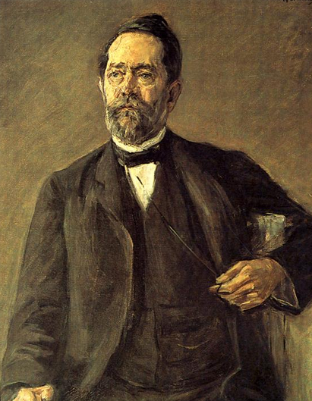



A German mathematician whose unified view of geometry as the study of the properties of a space that are invariant under a given group of transformations, known as the Erlanger Programm, profoundly influenced mathematical developments. Beyond his own work Klein made his greatest impact on mathematics as the principal architect of the modern community of mathematicians at Göttingen, which emerged as one of the world’s leading research centres under Klein and David Hilbert (1862–1943) during the period from 1900 to 1914.

Read more: http://blogs.smithsonianmag.com/science/2011/10/five-historic-female-mathematicians-you-should-know/#ixzz2hGNMgdc9
Follow us: @SmithsonianMag on Twitter

Felix Klein
1849-1925

