
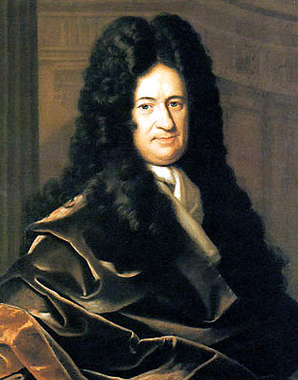


Gottfried Wilhelm Leibniz
He was one of the great thinkers of the seventeenth and eighteenth centuries and is known as the last “universal genius”. He made deep and important contributions to the fields of metaphysics, epistemology, logic, philosophy of religion, as well as mathematics, physics, geology, jurisprudence, and history. Leibniz made many contributions to the study of differential equations discovering the method of separation of variables, reduction of homogeneous equations to separable ones, and the procedure for solving first order linear equations. He used the idea of the determinant 50 years before Cramer, and did work on the multinomial theorem.

Read more: http://blogs.smithsonianmag.com/science/2011/10/five-historic-female-mathematicians-you-should-know/#ixzz2hGPhtEGB
Follow us: @SmithsonianMag on Twitter

Read more: http://blogs.smithsonianmag.com/science/2011/10/five-historic-female-mathematicians-you-should-know/#ixzz2hGNMgdc9
Follow us: @SmithsonianMag on Twitter

1646-1716

