
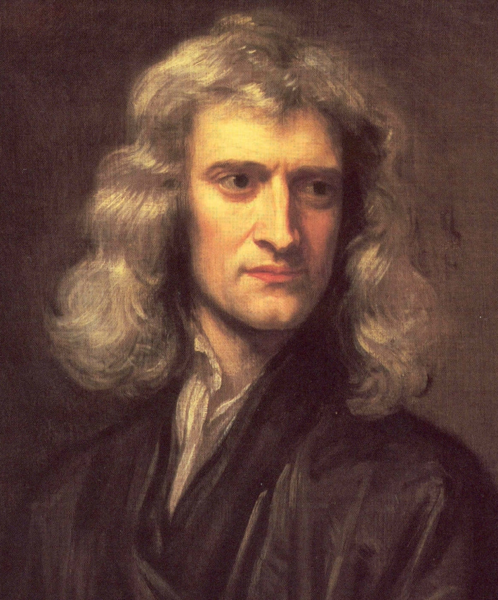


He has been described by some as "one of the greatest names in human thought". Newton was responsible for discovering many outstanding scientific and mathematical concepts.
He came up with the Binomial Theorem and was one of the two creators of calculus. These discoveries represented a quantum leap in the fields of math and science allowing for calculations that more accurately modeled the behavior of the universe than ever before. Without these advances in math, scientists could not design vehicles to carry us and other machines into space and also plot the best and safest course. Calculus gave scientist the tools to set up a theoretical model of a situation and still account for varying factors.
Sir Isaac Newton
(1642-1727)

