
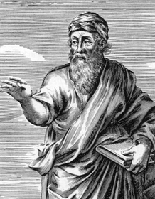


Pythagoras of Samos is often described as the first pure mathematician. He is an extremely important figure in the development of mathematics yet we know relatively little about his mathematical achievements. Unlike many later Greek mathematicians, where at least we have some of the books which they wrote, we have nothing of Pythagoras's writings. The society which he led, half religious and half scientific, followed a code of secrecy which certainly means that today Pythagoras is a mysterious figure.
PYTHAGORAS
circa 500 B.C.

