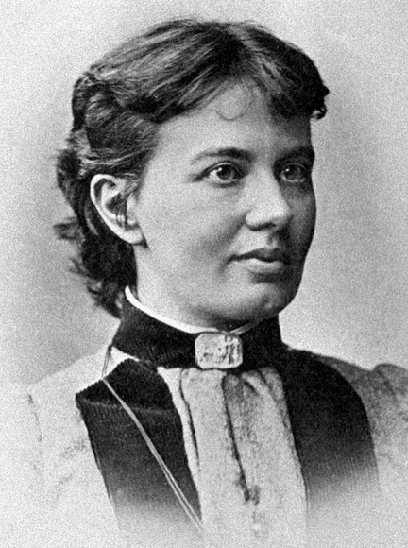

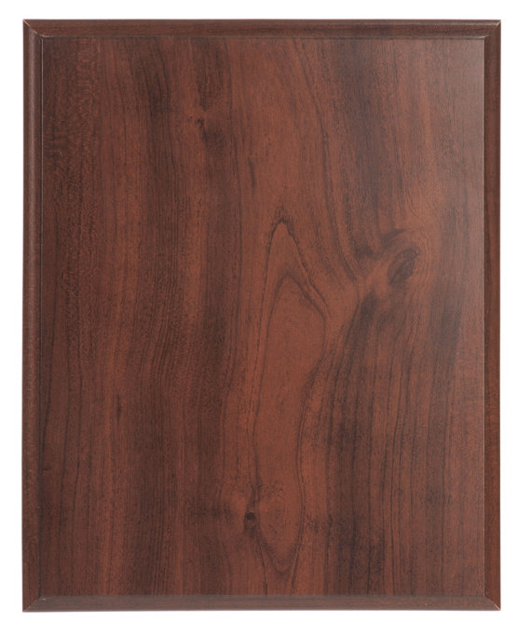

Because Russian women could not attend university, Sofia Vasilyevna contracted a marriage with a young paleontologist, Vladimir Kovalevsky, and they moved to Germany. There she could not attend university lectures, but she was tutored privately and eventually received a doctorate after writing treatises on partial differential equations, Abelian integrals and Saturn’s rings. Following her husband’s death, Kovalevskaya was appointed lecturer in mathematics at the University of Stockholm and later became the first woman in that region of Europe to receive a full professorship. She continued to make great strides in mathematics, winning the Prix Bordin from the French Academy of Sciences in 1888 for an essay on the rotation of a solid body as well as a prize from the Swedish Academy of Sciences the next year.
Read more: http://blogs.smithsonianmag.com/science/2011/10/five-historic-female-mathematicians-you-should-know/#ixzz2hGPhtEGB
Follow us: @SmithsonianMag on Twitter

Read more: http://blogs.smithsonianmag.com/science/2011/10/five-historic-female-mathematicians-you-should-know/#ixzz2hGNMgdc9
Follow us: @SmithsonianMag on Twitter

1850-1891
Sofia Kovalevskaya

