Sec 1.8 CC Geometry – Polygons & Quadrilaterals Name:

Polygon: A closed plane figure formed by three or more segments such that each segment intersects exactly two other segments only at their endpoints and no two segments with a common endpoint are collinear.

Regular Polygon: A polygon that is both equilateral and equiangular

Determine whether each figure below is a polygon or not a polygon.
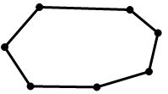
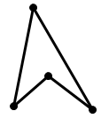
- 2. 3.

Circle one of the following:
Not a
Polygon
It is a
Polygon
Name if
Polygon:
Circle one of the following:
Not a
Polygon
It is a
Polygon
Name if
Polygon:
Circle one of the following:
Not a
Polygon
It is a
Polygon
Name if
Polygon:

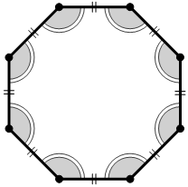
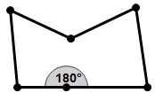
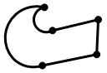
- 5. 6.

Circle one of the following:
Not a
Polygon
It is a
Polygon
Name if
Polygon:
Circle one of the following:
Not a
Polygon
It is a
Polygon
Name if
Polygon:
Circle one of the following:
Not a
Polygon
It is a
Polygon
Name if
Polygon:

Concave Polygon: A polygon in which a diagonal can be drawn such that part of one of the diagonals contains point in the exterior of the polygon.

Convex Polygon: A polygon in which no diagonal contains points in the exterior of the polygon.

Determine whether each figure below is a Convex or Concave.
7. 8. 9.

Circle one of the following:
CONCAVE
CONVEX
Circle one of the following:
CONCAVE
CONVEX
Circle one of the following:
CONCAVE
CONVEX

M. Winking (Section 1-8)

p.35

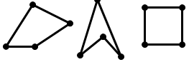
Quadrilateral: A four-sided polygon.
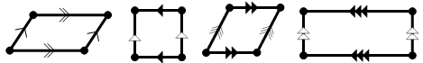

Parallelogram: A quadrilateral with two pairs of parallel sides.

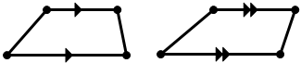
Trapezoid: A quadrilateral with exactly one pair of parallel sides.

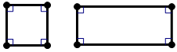
Rectangle: A quadrilateral with four right angles.

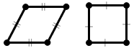
Rhombus: A quadrilateral with four congruent sides.

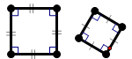
Square: A quadrilateral with four congruent sides and four right angles.

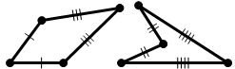
Kite: A quadrilateral with exactly two pairs of congruent consecutive sides but opposite sides are not congruent.

The Hierarchy of Quadrilaterals
Convex Quadrilateral
Concave
Quadrilateral
Parallelograms
Rhombi.
Squares .
Rectangles.
Trapezoids .
Kites .

Answer each of the following with ALWAYS, SOMETIMES, or NEVER

- A square is a rhombus.
- A rhombus is a square.
- A trapezoid is a parallelogram.
- A rectangle is a rhombus.
- A kite is a concave quadrilateral.
- A parallelogram is a rectangle.
- A rhombus is a trapezoid.
- A convex quadrilateral is a trapezoid.
- A rectangle is a parallelogram.

M. Winking (Section 1-8)

p.36

Using your knowledge of congruent triangles and parallel triangles determine the highest level and most appropriate definition of a quadrilateral for each ABCD quadrilateral below. Each definition in the word wall should be used exactly once. Briefly explain why for each quadrilateral.
Kite
Square
Concave-Quadrilateral
Trapezoid
Parallelogram
Convex-Quadrilateral
Rectangle
Rhombus

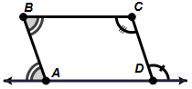
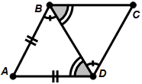
- 2.

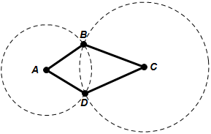
Both dashed figures can
be assumed to be circles.
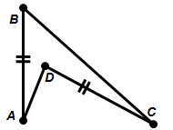
- 4.

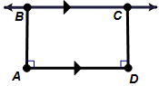
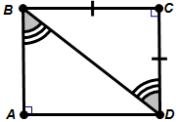
$∡ABD$ and $∡CBD$
are complimentary
- 6.

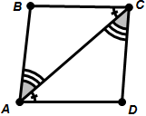
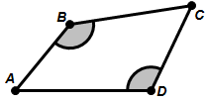
- 8.

p.37

M. Winking (Section 1-8)

