
- Sec 6.4– Applications of Probability
Conditional Probability Name:

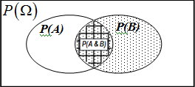
P(A | B) asks that we find the probability of A given that we know B has or already occurred. Using a formula find the probability of A given B can be found using $P(A | B) =\frac{P\left(A and B\right)}{P\left(B\right)}$

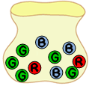
CONDITIONAL PROBABILITY

- Determine the following conditional probabilities.
Consider a bag with marbles, 3 blue marbles, 2 red marbles, and 5 green marbles. Three marbles are drawn in sequence and are taken without replacement.

Reduced Fraction:
Reduced Fraction:
i. P(2nd draw: blue | 1st draw: red) = ii. P P(2nd draw: blue | 1st draw: blue) =

Reduced Fraction:
Reduced Fraction:
iii. P(3rd draw: blue | 1st draw: red, 2nd draw: blue) = ii. P P(1st draw: blue | 1st draw: red) =

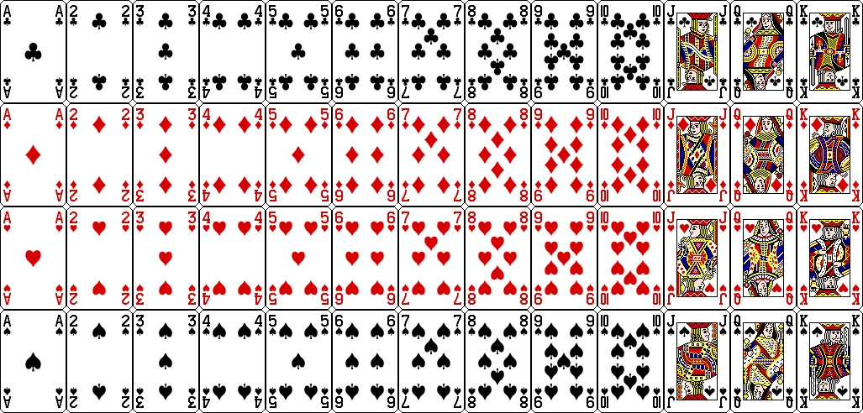
- Determine the following conditional probabilities.
Consider drawing 1 card from a standard deck of shuffled cards:
Reduced Fraction:

- P( Queen | Face Card ) =

Reduced Fraction:
- P( Ace | Lettered Card) =

Reduced Fraction:

- P( Heart with a Number | Red Card) =

Reduced Fraction:

- P( Card with a Letter| King) =

Reduced Fraction:
Reduced Fraction:
- P(number less than 6 | Face Card) =

- P( Odd Number | Numbered Card) =

- Consider the following table with information about all of the students taking Statistics at Phoenix High School.
 | Full-time | Part-Time | Total
Female | 28 | 15 | 43
Male | 12 | 16 | 28
Total | 40 | 31 | 71

Reduced Fraction:
Reduced Fraction:
Reduced Fraction:

  - P( Full-time | Male) =
Reduced Fraction:
  - P( Male | Full-time) =
  - P( Female | Part-time) =
  - P( Full-time | Part-time) =
M. Winking Unit 6-4 page 157

- Given the following VENN Diagram answer the following.
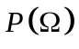
P(A)
P(B)
0.3
0.2
0.1
0.4
Decimal:
Decimal:
Decimal:
  - P( A | B ) = B. P( B | A ) =
Decimal:
- P( A | B’ ) = D. P( B | A’ ) =

- Given the P(B) = 0.6 and P(A | B) = 0.2 , determine the P(A and B).

P(A)
P(B)
0.16
- Given the VENN Diagram and P(A) = 0.8 and P(B | A) = 0.3
A. Determine the P(A and B)

B. Determine the P(B)

C. Determine the P(B’ ∩ A) D. Determine the P( (A ∪ B)’)

7. Also, two events can be determined to be independent if P (A|B) = P(A) and P(B|A) = P(B). Can you explain why?
M. Winking Unit 6-4 page 157

