
- Sec 5.2 – Circles & Volume
Volume of Pyramids & Cones Name:
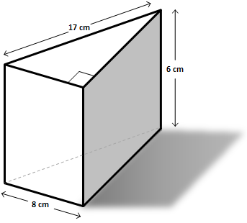
- Find the Volume of the following solids (figures may not be drawn to scale).

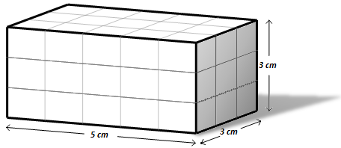

Volume:

Volume:

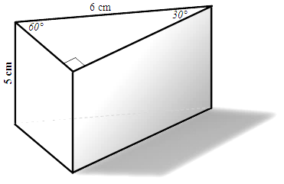
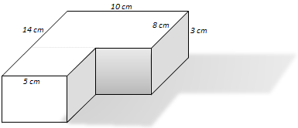

Volume:

Volume:

M. Winking Unit 5-2 page 1

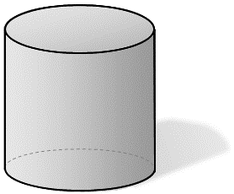
- Find the Volume of the following solids (figures may not be drawn to scale).
4 cm
12 cm

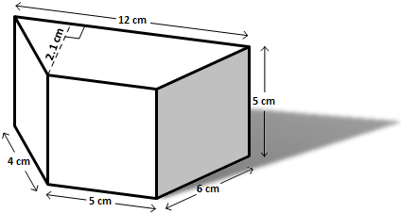

Volume:

Volume:

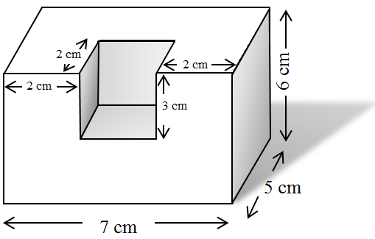
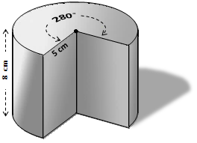

Volume:

Volume:

M. Winking Unit 5-2 page 2

- Find the volume of the following solids (figures may not be drawn to scale).
Using a micrometer find the volume of 6 pennies stacked on top of each other but so that they are slanted. Show measurements to the nearest hundredth of a millimeter.
Using a micrometer find the volume of 6 pennies stacked directly on top of each other (which is a cylinder). Show measurements to the nearest hundredth of a millimeter.

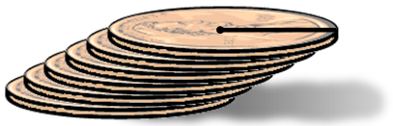
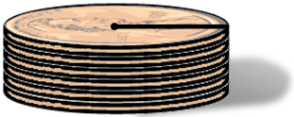

Volume:

Volume:

Find volume of the sphere.
Find volume of the oblique rectangular prism.

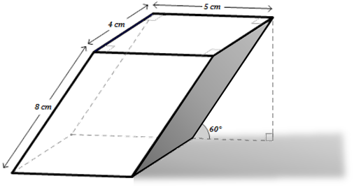
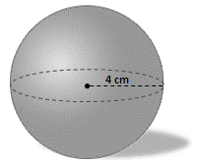

Volume:

Volume:

M. Winking Unit 5-2 page 3

- Find the volume of the following solids (figures may not be drawn to scale).
A sphere is inscribed in a cube with a volume of 27 cm³. What is the volume of the sphere?
The solid below shows a gas tank for a tractor trailer truck. It is in the shape of a cylinder with a radius of 9 inches and a height of 60 inches. How many gallons of fuel will it hold if there are 231 cubic inches in one gallon?

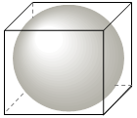
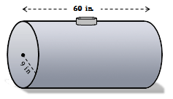

Volume:

Gallons:

A snowman is created from two spherical snow balls. Given the circumference of each sphere determine the volume of the snowman.
Find volume of the regular hexagonal prism.

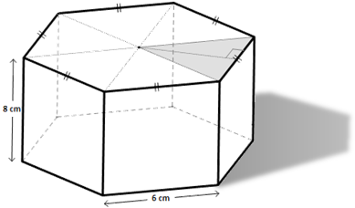
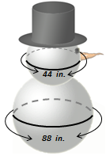

Volume:

Volume:

M. Winking Unit 5-2 page 4

