
Sec 5.3 – Circles & Volume
Volume of Pyramids & Cones Name:
Using Cavalieri’s Principle we can show that the volume of a pyramid is exactly ⅓ the volume of a prism with the same Base and height.

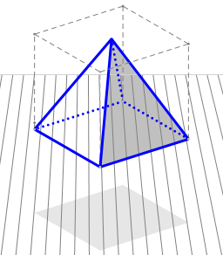 | 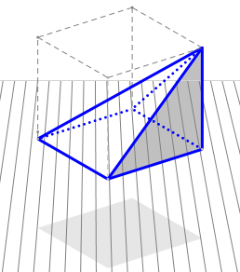 | 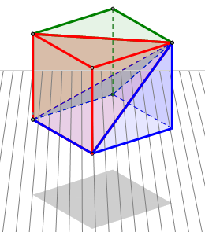
Consider a square based pyramid inscribed in cube. | Next, translate the peak of the pyramid. Cavalieri’s Principle would suggest that the volume of the oblique pyramid is the same as the original pyramid. | Next, we can create 2 more oblique pyramids with the same volume of the original with the remaining space in the cube.

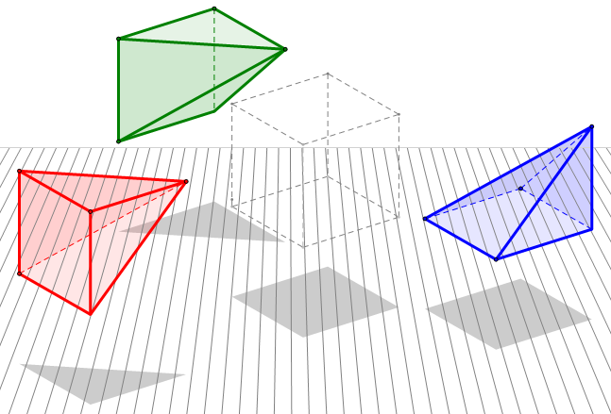
In this diagram, we can see the 3 oblique pyramids of equal volume pulled out from the cube. So, this demonstrates a pyramid inscribed in a cube has exactly ⅓ the volume the cube.
This idea can be extended to any pyramid or cone.

M. Winking Unit 5-3 page 1

- Find the Volume of the following solids (figures may not be drawn to scale).
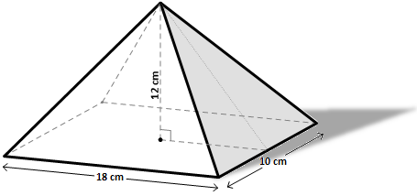

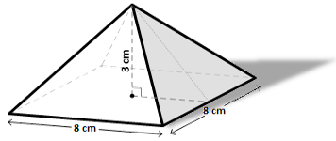

Volume:

Volume:

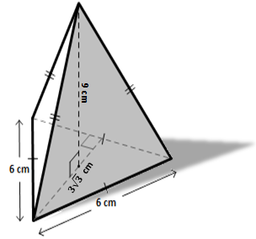
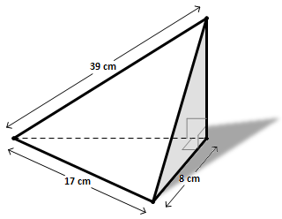

Volume:

Volume:

M. Winking Unit 5-3 page 2

- Find the Volume of the following solids (figures may not be drawn to scale).
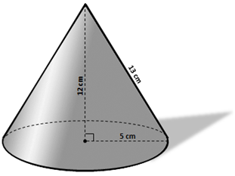
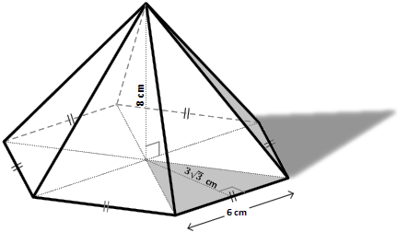

Volume:

Volume:

Find the volume of the irregular solid. The base has an area of 80cm² and a height of 9 cm.
Find the volume of the regular octahedron.

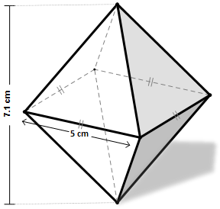

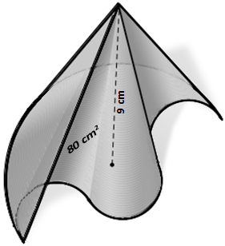

Volume:

Volume:

M. Winking Unit 5-3 page 3

- Find the Volume of the following solids (figures may not be drawn to scale).
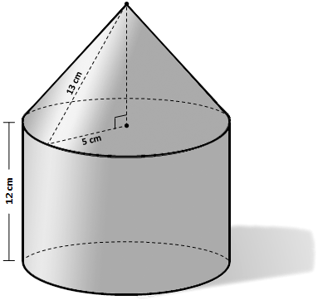

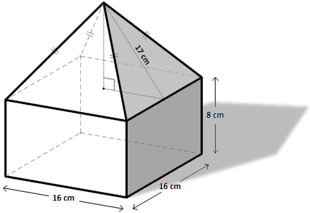

Volume:

Volume:

Consider triangle ABC with vertices at A (0,0), B(4, 6), and C(0,6) plotted and a coordinate grid. Determine the volume of the solid created by rotating the triangle around the y-axis.
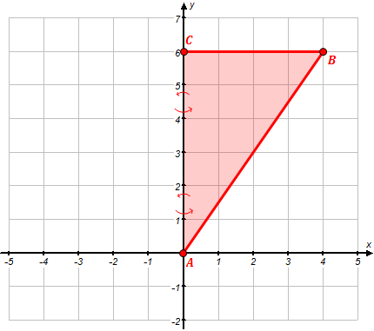

Volume:

M. Winking Unit 5-3 page 4

Using Cavalieri’s Principle we can show that the volume of a sphere can be found by $\frac{4}{3}π∙r^{3}$
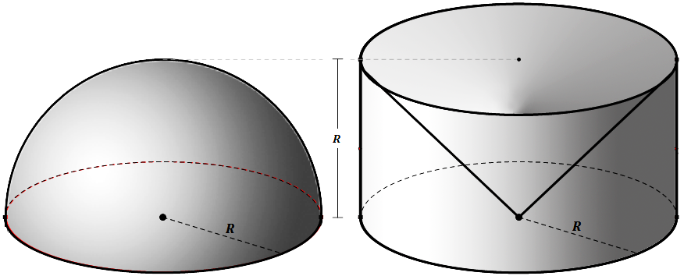 | First, consider a hemisphere with a radius of R. Create a cylinder that has a base with the same radius R and a height equal to the radius R. Then, remove a cone from the cylinder that has the same base and height.
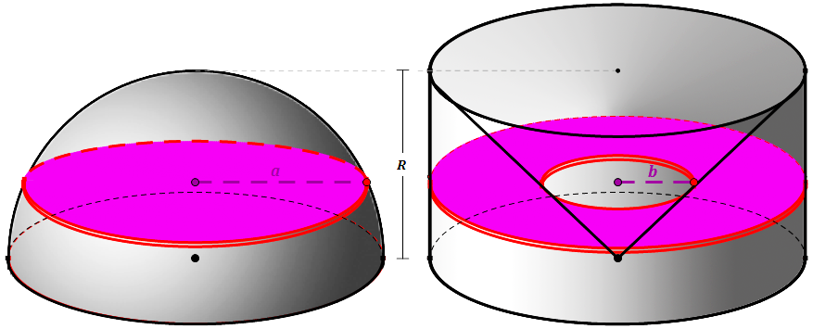 | Next, consider a cross section that is parallel to the base and cuts through both solids using the same plane.
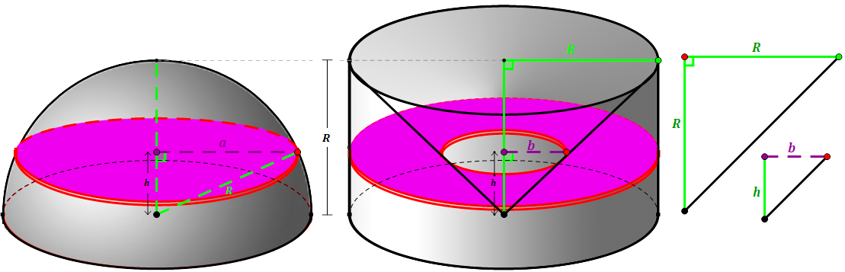

Cavalieri’s Principle suggests if the 2 cross sections have the same area then the 2 solids must have the same volume.

The area of the cross section of the sphere is:  $$CA=π∙a^{2}$$  Using the Pythagorean theorem we know:  $a^{2}+ h^{2}=R^{2}$ or $a^{2}=R^{2}- h^{2}$  So, with simple substitution:  $$CA=π∙\left(R^{2}- h^{2}\right)= {πR}^{2}- {πh}^{2}$$ | The area of the cross section of the second solid is:  $$CA=π∙R^{2}- π∙b^{2}$$  Using similar triangles we know that h = b and then, using simple substitution  $$CA=π∙R^{2}- π∙h^{2}$$
Volume of Hemisphere = Volume of Cylinder – Volume of Cone = $π∙R^{2}h- \frac{1}{3}π∙b^{2}h$
We also know that R = b = h. So, Volume of Hemisphere =$π∙R^{2}\left(R\right)- \frac{1}{3}π∙R^{2}\left(R\right)=π∙R^{3}- \frac{1}{3}π∙R^{3}=\frac{2}{3}π∙R^{3}$
To find the volume of a complete sphere, we can just double the hemisphere: Volume of Sphere = $=\frac{4}{3}π∙R^{3}$
M. Winking Unit 5-3 page 5

