
Sec 5.1 – Exponential & Logarithmic Functions
(Exponential Models) Name:

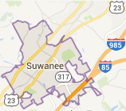

- The population of the city Suwanee, GA has consistently grown by 4% for the last several years. In the year 2000, the population was 9,500 people.

What would be the growth factor (multiplier)?

If the trend continues what would be the population in 2020?

- Lisa purchases a house for $150,000 near Lake Jackson. The value of houses in the area where the house was purchased is averaging an increase of 6% per year.

What would be the growth factor (multiplier)?

If the trend continues how much would the house be worth 12 years after Lisa purchased the house?

- Esther purchased a used car, a Ford Focus, for $8400. The car is expected to decrease in value by 20% per year over the next couple of years.


What would be the decay factor (multiplier)?

If the trend continues how much would the car be worth 6 years after Esther purchased the car?

- Freddie purchased a pair of never worn Vintage 1997 Nike Air Jordan XII Playoff Black Varsity Shoe Size 12 for $380. The shoes have shown an average growth rate of 14% per year.


What would be the growth factor (multiplier)?

If the trend continues how much would the shoes be worth 5 years after Freddie purchased the shoes?
M. Winking Unit 5-1 page 79

- A culture of bacteria triples by the end of each hour. There were initially 50 bacteria present in the petri dish.
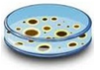
What would be the growth factor (multiplier)?

If the trend continues how many bacteria would there be 5 hours after the analysis began?
M. Winking Unit 5-1 page 79

- Consider starting with 2 pennies. Flip them both and for each one that lands heads up, add a penny to the pile. So, the pile should increase in size. Again, flip the new pile of pennies which could be a size of 2, 3, or 4. For every penny that lands heads up add another penny to the pile. Repeat this process several times and record how the penny pile grows after each flip. Your values may differ on Flips 3 and 4.

Number of Flips | Number of Pennies
0 | 2
1 | 3
2 | 5
3
4
5
6
7

Flip #1 | Flip #2

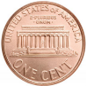
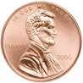
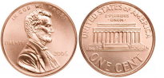

Add a penny since this one landed heads up.
Add a penny since this one landed heads up.

Add another penny since this one landed heads up.



Create a graph of the data.

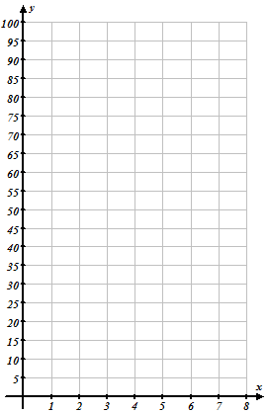
- What is an appropriate growth factor (multiplier)?

- Create an equation that describes the relationship between the number of flips and the number of pennies in the pile.

- Approximately how many pennies would there be on the 9th flip?
Number of Coins

- Should the graph be continuous or discrete? Explain.

- What is an appropriate Domain and Range for the situation?

M. Winking Unit 5-1 page 80

Number of Coin Flips

- Determine which of the following functions are exponential models of Growth and which are models of Decay.
- $f\left(x\right)=2∙{\left(1.05\right)}^{x}$ b. $g\left(x\right)=540∙{\left(0.92\right)}^{x}+1$ c. $h\left(x\right)=4{∙\left(\frac{3}{5}\right)}^{x}$

Circle the Answer
Growth Decay Neither
Circle the Answer
Growth Decay Neither
Circle the Answer
Growth Decay Neither

- $y=230∙{\left(\frac{7}{5}\right)}^{x}$ e. $y=4200∙e^{x}-5$ f. $y=9{∙\left(2\right)}^{-x}$

Circle the Answer
Growth Decay Neither
Circle the Answer
Growth Decay Neither
Circle the Answer
Growth Decay Neither

- $y=\frac{1}{4}∙{\left(3\right)}^{x}$ h. $p\left(x\right)=520∙e^{-x}+3$ i. $y=230{∙\left(\frac{2}{5}\right)}^{-x}$

Circle the Answer
Growth Decay Neither
Circle the Answer
Growth Decay Neither
Circle the Answer
Growth Decay Neither

n = 1 :Annually
n = 2 :Semi-Annually
n = 4 :Quarterly
n = 12 :Monthly
n = 52 :Weekly
n = 365 :Daily

A = Value of Account after Compounding
P = Original Amount Invested
r = Annual Interest Rate as a decimal
n = Compounds per Year
t = Number of Years Interest is Accrued
- Consider the Compound Interest Formula: $A=P{\left(1+\frac{r}{n}\right)}^{nt}$
- Determine the value of an account in which a person invested $6000 for 12 years at an annual rate of 9% compounded annually (n = 1).

- Determine the value of an account in which a person invested $6000 for 12 years at an annual rate of 9% compounded quarterly (n = 4).

- Determine the value of an account in which a person invested $6000 for 12 years at an annual rate of 9% compounded weekly (n = 52).

A = Value of Account after Compounding
P = Original Amount Invested
r = Annual Interest Rate as a decimal
t = Number of Years Interest is Accrued
- Consider the Compound Interest Formula: $A=P∙e^{rt}$
Determine the value of an account in which a person invested $6000 for 12 years at an annual rate of 9% compounded continuously.

M. Winking Unit 5-1 page 81

