
Sec 5.8 – Sec 6.1 – Mathematical Modeling
(Arithmetic & Geometric Sequences) Name:
ARITHMETIC SEQUENCES. Find the next few terms in the sequence and then find the requested term.
- 2 , 4 , 6 , 8 , _____ , ______ , ______ …...... Find a42=

Determine the RECURSIVE DEFINITION: Determine the EXPLICIT DEFINITION:

2) 5 , 8, 11 , 14 , ______ , ______ , ______ …...... Find a33=

Determine the RECURSIVE DEFINITION: Determine the EXPLICIT DEFINITION:

3) 10 , 7 , 4, 1, _____ , ______ , ______ …...... Find a29=

Determine the RECURSIVE DEFINITION: Determine the EXPLICIT DEFINITION:
M. Winking Unit 6-1 page 102

4) Josh was making a sequence pattern out of triangle pattern blocks.
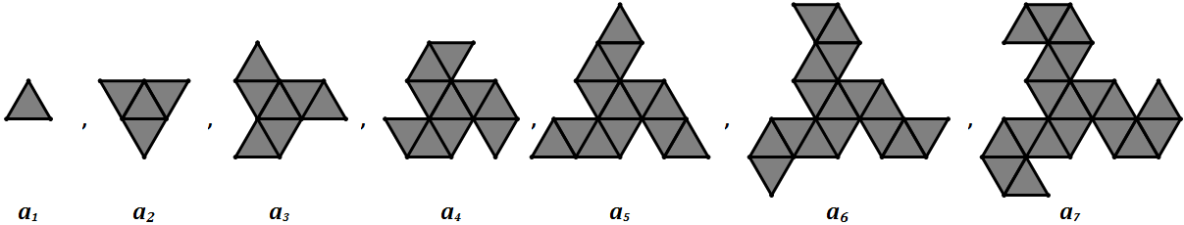

If Josh continues this pattern, how many triangles will he need to make the 20th step of this pattern?

Functions can be used as explicit definitions for a sequence:
Consider the sequence: 4, 7, 10, 13, 16, 19, 22, 25,………. The function $f\left(x\right)=4+\left(x-1\right)3$ could be used define the sequence where x = the term number. The domain would be {1, 2, 3, 4, ……} and the range would be {4, 7, 10, 13, ……}
5) Create a sequence based on the function: $f\left(x\right)=4x-1$

6) Describe the domain and range of a function that might describe the sequence of {14, 11, 8, 5, ……}

7) Determine the common difference of the sequence and write a function that could be used to describe the sequence: {14, 11, 8, 5, ……}

8) Write a recurrence relation and an explicit definition for the following table:

RECURRENCE RELATION: EXPLICIT DEFINITION:
M. Winking Unit 6-1 page 103

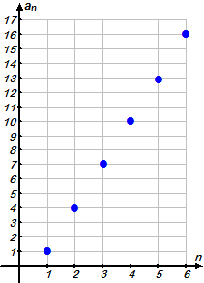
9) Write a recurrence relation and an explicit definition for the following graph:

RECURRENCE RELATION: EXPLICIT DEFINITION:

GEOMETRIC SEQUENCES. Find the next few terms in the sequence and then find the requested term.

10) 3 , 6 , 12 , 24 , _____ , ______ , ______ …...... Find a24=

RECURRENCE RELATION: EXPLICIT DEFINITION:

11) 2 , – 6, 18 , – 54 , ______ , ______ , ______ …...... Find a16=

RECURRENCE RELATION: EXPLICIT DEFINITION
M. Winking Unit 6-1 page 104

12) Create a sequence based on the function: $f\left(x\right)=5∙2^{x}$

13) Write a recurrence relation and an explicit definition for the following table:
RECURRENCE RELATION:
EXPLICIT DEFINITION:
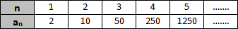

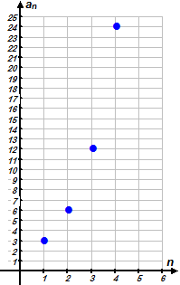

14) Write a recurrence relation and an explicit definition for the following graph:

RECURRENCE RELATION: EXPLICIT DEFINITION:

SEQUENCES

15) Given that a sequence is arithmetic , a₁ = 5, and the common difference is 4, find a₃₇.

16) Given that a sequence is arithmetic , a₅₂ = 161, and the common difference is 3, find a₁.

17) Given that a sequence is geometric , the first term is 1536, and the common ratio is ½ , find the 7th term in the sequence.

18) Given that a sequence is geometric , a₁₀ = 98415, and the common ratio is 3 , find a₁.

M. Winking Unit 6-1 page 105

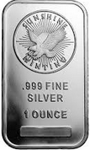
19) The value of an ounce of silver is about $16 and over the last several years silver has increased in value by about 7%. How much should an ounce of silver be worth 20 years from now?


20) A person was having a graduation party and noticed that only 5 people were there after the first hour but grew in size by 61% every hour. If the size of the party grew this way for 6 hours, how many people would be at the party on the 6th hour?

21) Jessica is creating a drawing on her paper called a Binary Tree.

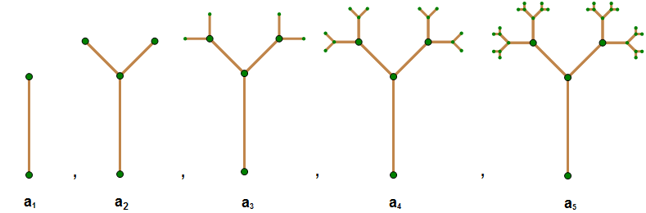

If Jessica continue drawing more and more branches, how many new branches would she need to draw on the 12th step?

M. Winking Unit 6-1 page 106

