
Sec 6.4 – Mathematical Modeling
(Systems by Equations) Name:
Each system of equation is shown in graph. Using the graph find the solutions to each of the systems.
1. $y=\frac{1}{3}x+3$ 2. $y=x^{2}-3$ 3. $y=2^{x}-2$
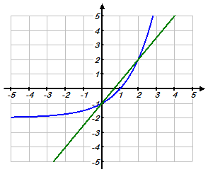
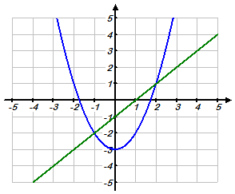
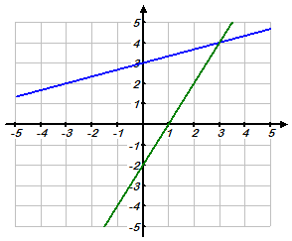
$y=2x-2$ $y=x-1$ $y=\frac{3}{2}x-1$

Which of the system of equations below have a solution of (– 3, 2) ?

4. $\left\{\begin{matrix}y=2x+8_{{}_{}} \\ {3x+2y=-5}^{}\end{matrix}\right.$ 5. $\left\{\begin{matrix} y=\frac{2}{3}x+4_{{}_{}} \\ {x=\frac{1}{2}y-2}^{}\end{matrix}\right.$ 6. $\left\{\begin{matrix} y+2x=-4_{{}_{}} \\ { 3}^{y}+x=6 \end{matrix}\right.$

Graph each system and use the graph to determine a solution.

7. $\left\{\begin{matrix} y=\frac{1}{2}x-4_{{}_{}} \\ {y+2x=1}^{}\end{matrix}\right.$ 8. $\left\{\begin{matrix} y=-3x-6_{{}_{}} \\ {-2x+3y=15}^{}\end{matrix}\right.$

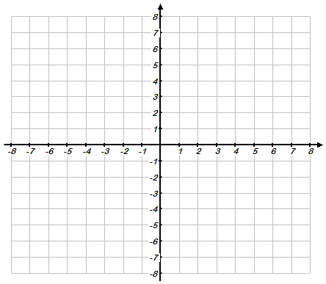

M. Winking Unit 6-4 page 116

Each system of equation is shown in graph. How many solutions does each system have?

9. $y=\frac{1}{2}x-2$ 10. $y=\frac{1}{3}x+1$ 11. $y=-\frac{2}{3}x+2$
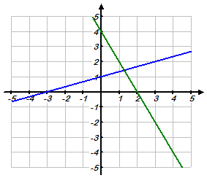
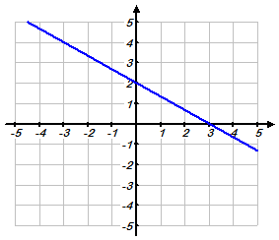
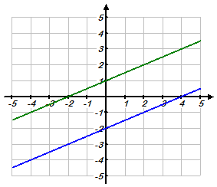
$y=\frac{1}{2}x+1$ $y=-2x+4$ $y=-\frac{2}{3}x+2$

Graph each system and use the graph to determine a solution.

12. $3y=2x-6$ 13. $4y-7=2x+1$ 141. $2x=y+2$
$4x-6y=12$ $2y-x=-6$ $3y=-2x+9$

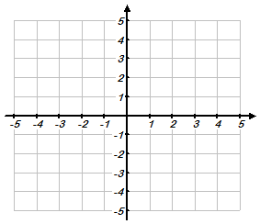

M. Winking Unit 6-4 page 117

Solve each of the following systems using the substitution method.

15. $y=2x+5$ 16. $4x+2y=4$

$3x+2y= -4$ $x-3y= 15$

Solve each of the following systems using the elimination method.

17. $2x-3y=9$ 18. $4x-2y=6$

$3x+4y=5$ $-6x+3y=-9$

M. Winking Unit 6-4 page 118

19. The Turbo Taxi Service charges a flat rate of $5 and then $0.40 per mile. The Express Taxi Company charges a flat rate of $2 and then $0.75 per mile.

- Write an equation that describes the cost, c, of each taxi cab in terms of miles, m, driven.

Turbo Taxi Service: c =


Express Taxi Co: c =

- When do the two taxi cabs charge the same amount?

- Describe when the Express Taxi Company charges more than Turbo Taxi Services.

20. A local school sold 230 tickets for their performance of Hamlet. They sold a combination of regular tickets and student tickets. The regular tickets sold for $8 each and the student tickets sold for $5. That night they collected $1522 in ticket sales.


  - Write an equation that describes each piece of information. Let ‘R’ represent the number of regular tickets and ‘S’ represent the number of Student tickets.

  - Using the system of equations determine the number of each type of ticket that was sold.

M. Winking Unit 6-4 page 119

Solve each of the following systems using the substitution method.

21. $y=2z$
$3x+2y -z= 3$
$$2x-y+ 4z = 2$$

Solve each of the following systems using the elimination method.

22. $3x+2y+ z=9$ $5x+4y-3z=-5$
$-2x+3y+5z=8$
M. Winking Unit 6-4 page 120

