
Sec 6.9 – Mathematical Modeling
(Transformations of Functions) Name:
It may help to first review some transformations on the graph. Transform the following points as suggested.

- Reflect point A over the x-axis and then translate the image right 2 units.

- Horizontally stretch point B by a factor of 3 from the y-axis and translate the image up 7 units.

- Vertically compress point C by a factor of ½ from the x-axis, reflect the image over the y-axis, and finally, translate that image right 1 unit.

- Reflect point D over the x-axis, then reflect that image over the y-axis, vertically stretch that image by a factor 2 from the x-axis, and finally translate the last image up 2
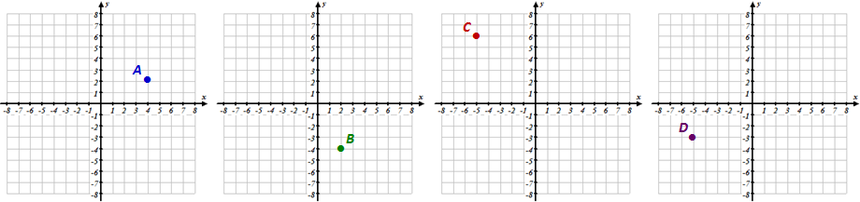

Consider the parent function of $f\left(x\right)$ . The following would be a transformed function

$$t\left(x\right)=a∙f\left(b\left(x-c\right)\right)+d$$

d =
Vertical

Translation

b > 1: Horizontal Compress (eg. b = 3)

0 < b < 1: Horizontal Stretch (e.g. b = 0.2)

-1 < b < 0: Reflect over y-axis &
Horizontal Stretch (e.g. b =- 0.2)

b = -1: Reflect over y-axis
b < -1: Reflect over y-axis &
Horizontal Compress (e.g. b =- 4)

a > 1: Vertical Stretch (eg. a = 3)

0 < a < 1:Vertical Compress (e.g. a = 0.2)

-1 < a < 0: Reflect over x-axis &
Vertical Compress (e.g. a =- 0.2)

a = -1: Reflect over x-axis
a < -1: Reflect over x-axis &
Vertical Stretch (e.g. a =- 4)

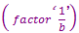
(factor ‘a’)
Horizontal

Translation

c =
(factor ‘a’)
(opposite direction)

(factor ‘a’)

(factor ‘a’)

First apply any reflections or stretches/compresses and then the translations
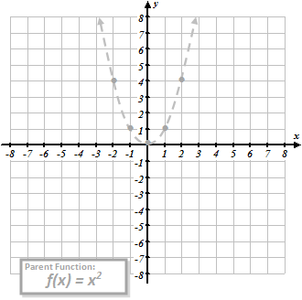
- At the right the parent graph of $f\left(x\right)=x^{2}$ is shown as a light gray dashed line. Describe the transformations of $f\left(x\right)$ that would be required to match the transformed function shown below and sketch a graph by transforming a few of the points of $f\left(x\right)$.

$$t\left(x\right)=2{\left(x-3\right)}^{2}-1$$

M. Winking Unit 6-9 page 131

- At the right the parent graph of $f\left(x\right)=x^{2}$ is shown as a light gray dashed line. Describe the transformations of $f\left(x\right)$ that would be required to match the transformed function shown below and sketch a graph by transforming a few of the points of $f\left(x\right)$.

$$t\left(x\right)=-{\left(2\left(x+3\right)\right)}^{2}$$

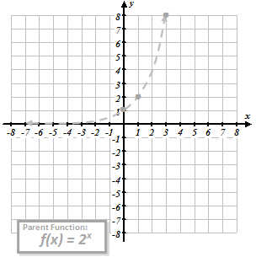
- At the right the parent graph of $f\left(x\right)=2^{x}$ is shown as a light gray dashed line. Describe the transformations of $f\left(x\right)$ that would be required to match the transformed function shown below and sketch a graph by transforming a few of the points of $f\left(x\right)$.

$$t\left(x\right)=2^{\left(\frac{1}{2}\left(x\right)\right)}-3$$

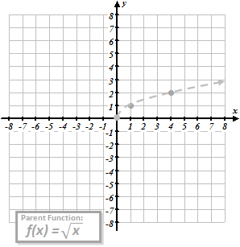
- At the right the parent graph of $f\left(x\right)=\sqrt{x}$ is shown as a light gray dashed line. Describe the transformations of $f\left(x\right)$ that would be required to match the transformed function shown below and sketch a graph by transforming a few of the points of $f\left(x\right)$.

$$t\left(x\right)=2\sqrt{-x}+1$$

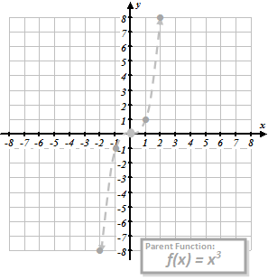
- At the right the parent graph of $f\left(x\right)=x^{3}$ is shown as a light gray dashed line. Describe the transformations of $f\left(x\right)$ that would be required to match the transformed function shown below and sketch a graph by transforming a few of the points of $f\left(x\right)$.

$$t\left(x\right)={\frac{1}{2}\left(x+5\right)}^{3}-1$$

M. Winking Unit 6-9 page 132

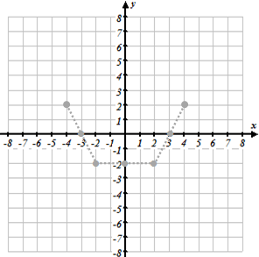
- At the right the parent graph of $f\left(x\right)$ is shown as a light gray dashed line. Describe the transformations of $f\left(x\right)$ that would be required to match the transformed function shown below and sketch a graph by transforming a few of the points of $f\left(x\right)$.

$$t\left(x\right)=3∙f\left(x\right)+2$$

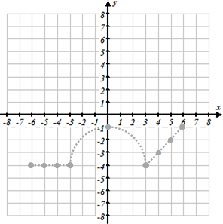
- At the right the parent graph of $f\left(x\right)$ is shown as a light gray dashed line. Describe the transformations of $f\left(x\right)$ that would be required to match the transformed function shown below and sketch a graph by transforming a few of the points of $f\left(x\right)$.

$$t\left(x\right)=-2∙f\left(x-1\right)-1$$

- Given a more elaborate parent function of $f\left(x\right)=x^{3}-x$, describe how the parent function could be graphically transformed to create the functions below:

a. $g\left(x\right)=4\left(x^{3}-x\right)$ b. $h\left(x\right)={\left(4x\right)}^{3}-\left(4x\right)$ c. $p\left(x\right)=-\frac{1}{3}\left({\left(x-2\right)}^{3}-\left(x-2\right)\right)+1$

- Describe g(x) as a transformation of f(x).
- Describe g(x) as a transformation of f(x).

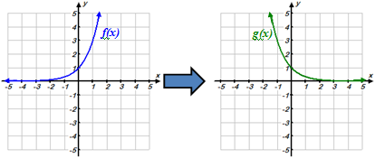
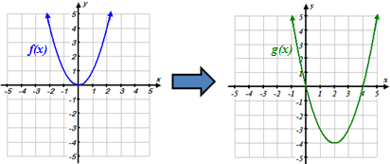

$$g\left(x\right)=$$
$$g\left(x\right)=$$
M. Winking Unit 6-9 page 133

- Describe g(x) as a transformation of f(x).

- Describe g(x) as a transformation of f(x).

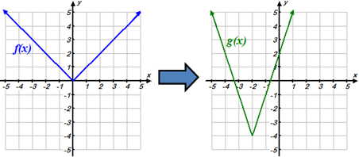
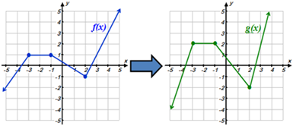

$$g\left(x\right)=$$
$$g\left(x\right)=$$

- Consider the partial set of values of the function $f\left(x\right)$, shown below. Determine the missing values in the second table given that $t\left(x\right)$ is the same as $f\left(x\right)$ translated up 3 units.

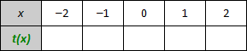
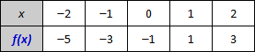

- Consider the partial set of values of the function $f\left(x\right)$, shown below. Determine the missing values in the second table given that $t\left(x\right)$ is the same as $f\left(x\right)$ translated right 2 units and down 2 unit.

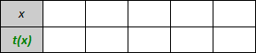
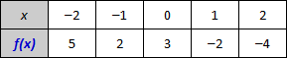

- Consider the partial set of values of the function $f\left(x\right)$, shown below. Determine the missing values in the second table given that $t\left(x\right)$ is the same as $f\left(x\right)$ vertically stretched by a factor of 2 from the x-axis.

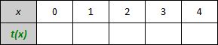
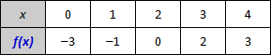

- Consider the partial set of values of the function $f\left(x\right)$, shown below. Determine the missing values in the second table given that $t\left(x\right)$ is the same as $f\left(x\right)$ reflected over the x-axis.

M. Winking Unit 6-9 page 134

