
Sec 2.2 – Exponential & Logarithmic Functions
(Graphing Exponential Functions) Name:

- Consider the exponential function , $f\left(x\right)=3^{x}$.
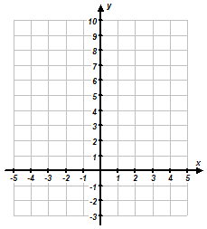
A. Fill in the missing values in the table below. B. Plot the points from the table and sketch a graph
Label any asymptotes.
x | f(x)
2
0
 | 27
1
–1
–3

C. Determine the Domain & Range of the function.

- Consider the exponential function , $g\left(x\right)=2^{x}-2$.
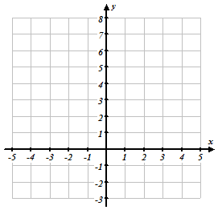
A. Fill in the missing values in the table below. B. Plot the points from the table and sketch a graph
Label any asymptotes.
x | g(x)
2
3
 | 0
0
–1
–3

C. Determine the Domain & Range of the function.

- Consider the exponential function , $h\left(x\right)={\left(\frac{1}{2}\right)}^{x}+1$.
A. Fill in the missing values in the table below. B. Plot the points from the table and sketch a graph
Label any asymptotes.
x | h(x)
–3
–1
0
1
2
3

C. Determine the Domain & Range of the function.

M. Winking Unit 2-2 page 37

- Determine the asymptote and sketch a graph (label the any intercepts, points when x = 0, and when x = 1.)
A. $f\left(x\right)=3^{x}-4$ B. $g\left(x\right)={\left( \frac{1}{2} \right)}^{x}+2$ C.$h\left(x\right)=-2^{x}-3$

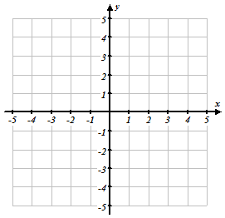

- Create two different exponential functions of the form $f\left(x\right)=a∙b^{x}+c$ that have a horizontal asymptote at $y=5$.

- Given the function$f\left(x\right)$ is of the form $f\left(x\right)=a∙b^{x}+c$ , has a horizontal asymptote at $y=-1$, and passes through the point $\left(0,2\right)$, create a possible function for $f\left(x\right)$.

- Consider t(x) is of the form $t\left(x\right)=a^{x}+c$.

- Consider w(x) is of the form $w\left(x\right)=a^{x}+c$.
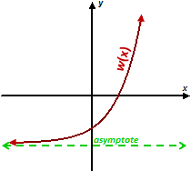

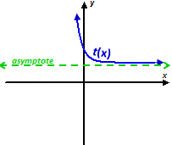

Which of the following must be true for the parameter ‘a’?
a > 1 0 < a< 1 a <0
Which of the following must be true for the parameter ‘c’?
c > 0 c = 0 c <0

Which of the following must be true for the parameter ‘a’?
a > 1 0 < a < 1 a <0
Which of the following must be true for the parameter ‘c’?
c > 0 c = 0 c <0

M. Winking Unit 2-2 page 38

- Determine the x-intercept and y-intercept of the following exponential functions:
- $r\left(x\right)={3∙2}^{x}-6$ b. $r\left(x\right)={-1∙3}^{x}+9$

- The parent graph is shown in light gray on the graph. Graph the transformed function on the same Cartesian coordinate grid and describe the transformations based on the function t(x).
- Parent Function: $f\left(x\right)=2^{x}$ b. Parent Function: $f\left(x\right)=2^{x}$
Transformed Function: $t\left(x\right)=2^{\left(x-2\right)}-6$ Transformed Function: $t\left(x\right)=2{∙2}^{\left(x-4\right)}$

Determine the Domain & Range of the function.
Determine the Domain & Range of the function.

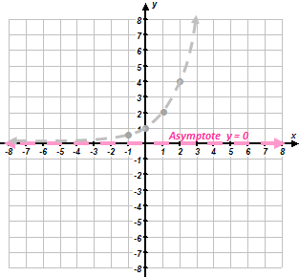

- Parent Function: $f\left(x\right)=3^{x}$ d. Parent Function: $f\left(x\right)=3^{x}$
Transformed Function: $t\left(x\right)=-3^{\left(x+3\right)}$ Transformed Function: $t\left(x\right)=3^{\left(-x\right)}+2$

Determine the Domain & Range of the function.
Determine the Domain & Range of the function.

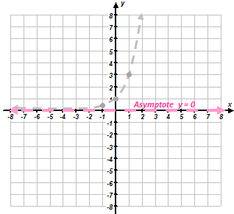

M. Winking Unit 2-2 page 39

- Given the graph of $f\left(x\right)$ on the left, determine an equation for $g\left(x\right)$ on the right in terms of $f\left(x\right).$
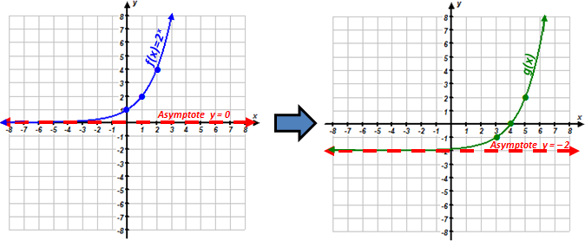
a.

$$g\left(x\right)=$$

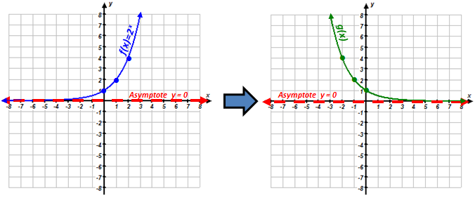
b.

$$g\left(x\right)=$$

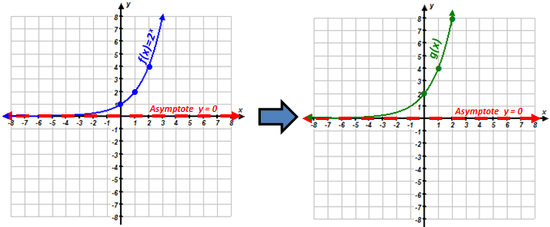
c.

M. Winking Unit 2-2 page 40

$$g\left(x\right)=$$
- Given a table of values for the exponential function $f\left(x\right)$ and a description of the transformations for the function g(x), fill out the table of values based on the original points for g(x), the transformed function.

Translated
Down 4
x | – 1 | 0 | 1 | 2 | 3
g(x)

x | – 1 | 0 | 1 | 2 | 3
f(x) | ⅓ | 1 | 3 | 9 | 27

Translated
Left 1 & Up 2
x
g(x)

x | – 1 | 0 | 1 | 2 | 3
f(x) | ½ | 1 | 2 | 4 | 8

Reflect over
x-axis
x
g(x)

x | – 1 | 0 | 1 | 2 | 3
f(x) | ¼ | 1 | 4 | 16 | 64

Vertical Stretch
of Factor 3
x
g(x)

x | – 1 | 0 | 1 | 2 | 3
f(x) | ½ | 1 | 2 | 4 | 8

- Given each of the graphs below are exponential functions of the form $f\left(x\right)=a^{x}$, determine the parameter ‘a’ in each graph.

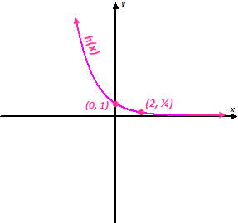
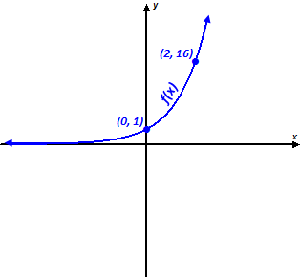
- b.

$$h\left(x\right)=$$
$$f\left(x\right)=$$
M. Winking Unit 2-2 page 41

