
Sec 2.5 – Exponential & Logarithmic Functions
(Inverses of Exponential and Log Functions) Name:
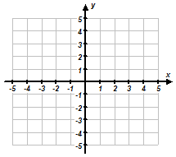
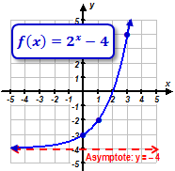
- Consider the exponential function $f\left(x\right)$ shown below. Find the inverse of the function, sketch a graph of the inverse, and determine whether or not the inverse is a function.
Graph of Inverse

Is the Inverse a Function?
YES NO

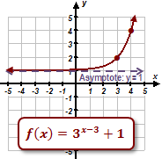
Graph of Inverse

Is the Inverse a Function?
YES NO

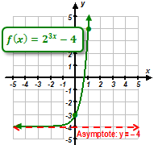
Graph of Inverse

Is the Inverse a Function?
YES NO

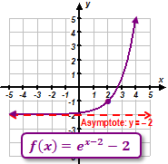
Graph of Inverse

M. Winking Unit 2-5 page 49

Is the Inverse a Function?
YES NO
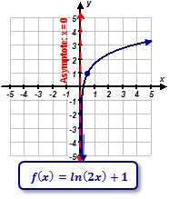
- Consider the logarithmic function $f\left(x\right)$ shown below. Find the inverse of the function, sketch a graph of the inverse, and determine whether or not the inverse is a function.
Graph of Inverse

Is the Inverse a Function?
YES NO

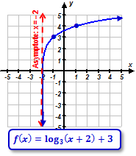
Graph of Inverse

Is the Inverse a Function?
YES NO

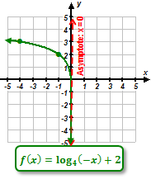
Graph of Inverse

Is the Inverse a Function?
YES NO

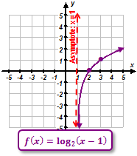
Graph of Inverse

Is the Inverse a Function?
YES NO
M. Winking Unit 2-5 page 50

