
Sec 7.5 – Rational Functions
Rational Functions in Context Name:
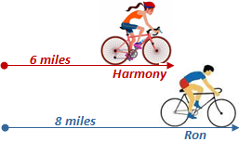
- Ron rode 8 miles on his bike in the same amount of time it took Harmony to ride 6 miles. Ron rides his bike at a rate of 4 miles per hour (mph) faster than Harmony.

How fast was Harmony riding on her bike?

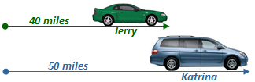
- Jerry drove his car a total of 40 miles in the same time it took his wife Katrina to drive 50 miles. Jerry drives his car at a rate of 10 miles per hour (mph) slower than Katrina.

How fast was Katrina driving?

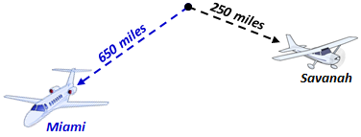
- A passenger jet flew from Atlanta to Miami (650 miles) in the same time it took a propeller plane to fly from Atlanta to Savanah (250 miles). The jet was flying at a rate of 400 miles per hour (mph) faster than the propeller plan.

How fast is the propeller plane flying?

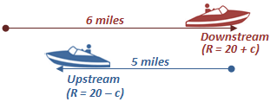
- A motorboat is traveling on the Mississippi River. The boat travels at 20 miles per hour (mph) in still water. The boat went 6 miles downriver with the current in the same amount of time it took the boat to travel 5 miles upstream against the current.

How fast is the current?

M. Winking Unit 7-5 © page 1

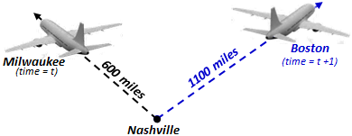
- Two planes left from Nashville at the same rate of speed. The first plane flew to Boston for a total of 1100 miles. The second plane flew to Milwaukee for a total of 600 miles. It took the first plane flying to Boston an hour longer to reach its destination. How long did it take the second plane to travel to Milwaukee?

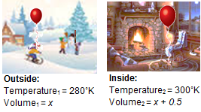
- A child went to a winter fair outside and got a balloon at the fair. The temperature outside was 280˚ Kelvin (about 44˚ F). When the child brought the balloon inside the temperature increased to 300˚ Kelvin (about 80˚ F). The balloon increased in size by 0.5 liters of air. How many liters of air did the balloon contain originally at the Fair?

Use Charles Law: $\frac{V_{1}}{T_{1}}=\frac{V_{2}}{T_{2}}$

A = Value of Account after Compounding
P = Original Amount Invested
r = Annual Interest Rate as a decimal
n = Compounds per Year
t = Number of Years Interest is Accrued
- Consider the Compound Interest Formula: $A=P{\left(1+\frac{r}{n}\right)}^{nt}$

- Determine the Value of an account in which a person invested $4000 for 8 years at an annual rate of 11% compounded quarterly (n = 4).

- Create a sketch of a graph showing the value of an account over t years given an initial investment of $500 at an annual rate of 12% compounded monthly (n = 12).
Years | Value
1
2
4
8
10
12
14
16
20

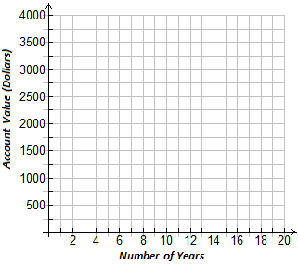

- Create a sketch of a graph showing the value of an account for different numbers of compounds per year given the initial investment of $100 at an annual rate of 15% compounded n times over the course of 20 years.
Compound | Value
1
2
3
4
6
8
10
12
14

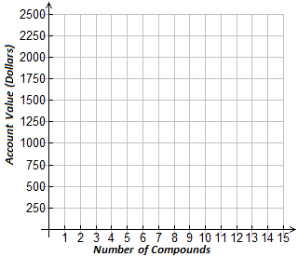

M. Winking Unit 7-5 © page 2
- Describe the domain and range of each function below as DISCRETE or CONTINUOUS
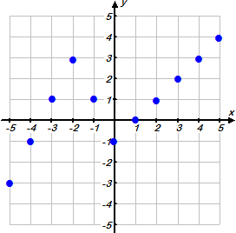
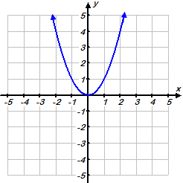
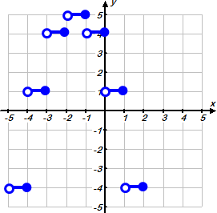

Domain:

Range:
Domain:

Range:
Domain:

Range:


- A postal company delivers packages based on their weight but will not ship anything over 50 pounds. The company charges $0.50 per pound to deliver the package anywhere in the United States. If we consider this situation a function where the number of pounds, x, is the independent variable and the cost in dollars, y, is the dependent variable determine the domain and range.
Domain:

Range:


- A limousine company rents their limousine by the hour. The company charges $85 per hour. The minimum time is 2 hours and a maximum of 12 hours. If we consider this situation a function where the number of hours, x, is the independent variable and the cost in dollars of renting the limousine, y, is the dependent variable determine the domain and range.
Domain:

Range:


- A student is growing a bean plant outside for a science project. The plants grow for 12 weeks before reaching their maximum height. The student consider the week she started growing the plant to be week 0 and then realized that the plant closely followed the function model $h\left(x\right)= 1.5∙{\left(1.2\right)}^{x}$, where x represents the number of weeks grown and $h\left(x\right)$ represents the height of the plant in inches. Using the function model describe the appropriate domain and range.
Domain:

Range:


- A vending company realized a relationship between the number of people present at the stadium during a Braves game and the number of hot dogs they sold. The minimum attendance due to players and support staff is 361 people and the maximum people that could be at the stadium is 86,436 people. The relationship that describes the number of hot dogs sold very closely followed the function model $h\left(x\right)= 15∙\sqrt{x}$ where x represents the number of people at the stadium and $h\left(x\right)$ represents the number of hot dogs sold. What is the domain and range of the model?
Domain:

Range:
M. Winking Unit 7-5 © page 3

