
Sec 1-4a – Trigonometry
Law of Sines Name:
A
C
B
c
a
h
(b - x)
x
Law of Sines: Start with sin (A) and sin(C).

PROOF :

- Find the unknown sides and angles of each triangle using the Law of Sines.
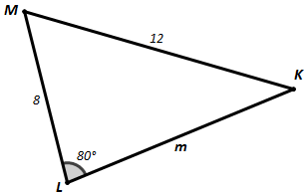
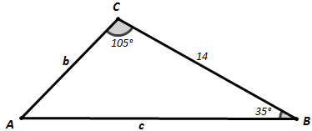

m
m∠M
m∠K
c
b
m∠A

M. Winking Unit 1-4 page 11
2. A student was trying to determine the height of the Washington monument from a distance. So, he measured two angles of elevation 44 meters apart. The angle of elevation the furthest away from the monument measured to be 25° and the closest angle of elevation measured 28°. The student determining the angles is 1.6 Meters tall from his feet to his eyeballs. Find the Height = Distance away =

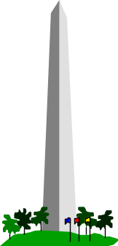
Height

25°
28°
44m
Distance

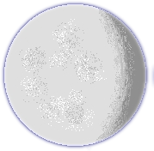
3. Two students that are on the same longitudinal line are approximately 5400 miles apart. The used an inclinometer, a little geometry, and a tangent line to determine the that 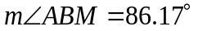 and 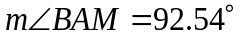. The two students form a central angle of 85.9º with the center of the earth. Given this information determine how far each student is away from the moon.
A
B
M
E
86.17º
92.54º
85.9º

M. Winking Unit 1-4 page 12
Use this information to find the radius of the Earth and then the circumference (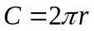).
Sec 1-4b – Trigonometry
Ambiguous Case of Law of Sines Name:
In some examples you may be provided with 3 measures of a triangle that can potentially describe more than one triangle. Consider triangle ABC with the following measures $m∡A=36°$, AB = 9 cm, and BC = 6 cm.
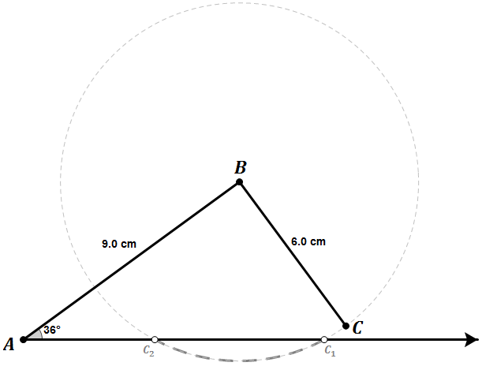

- First we could create a ray emanating from point A. Then, create a new ray emanating from A but at an angle of 36° from the first. Next, we could measure 9cm along the newly created ray and label the point B. Finally, create a circle with a center at B and a radius of 6 cm. If more than one triangle is possible the circle should intersect the original first ray twice. Each intersection represents a potential vertex C of a triangle with the given measures.

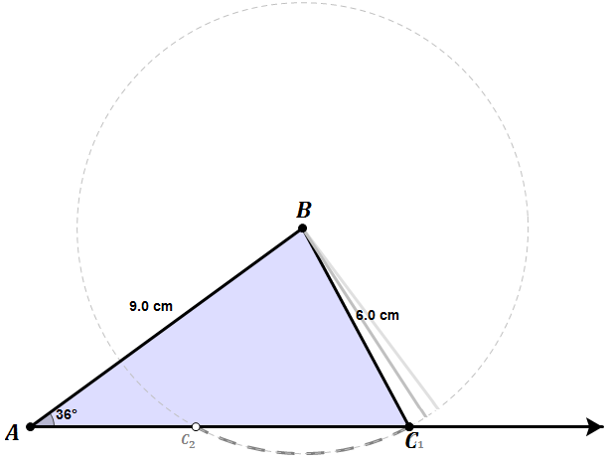

- The Standard or Regular Case. Usually this is represented by creating the triangle that has the longest possible side for the only side measure that was not given (in this example AC). We can use Law of Sines regularly in this example to find the unknown measures of the triangle.

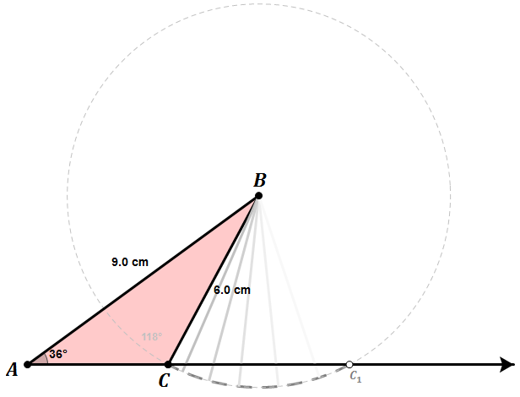

- The Ambiguous Case. Usually this is represented by creating the triangle that has the shortest possible side for the only side measure that was not given (in this example AC). To find the unknown measures of the ambiguous case, we will need to use geometry and law of sines.

M. Winking Unit 1-4 page 13
When provided with Side-Side-Angle (SSA) measures of a triangle with an acute angle, 1 of 4 situations can occur.
M. Winking Unit 1-4 page 14
Case #1: (No Triangle Possible)  Find the height of the triangle from point B to the ray emanating from point A.  $$AB∙sin\left(A\right)>BC$$  $$6∙sin\left(48°\right)>4$$  $$4.46>4$$ | 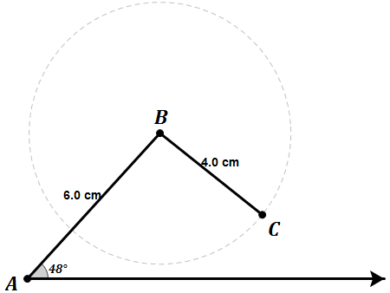
Case #2: (One Right Triangle Possible)  Find the height of the triangle from point B to the ray emanating from point A.  $$AB∙sin\left(A\right)=BC$$  $$6∙sin\left(30°\right)=3$$  $$3=3$$ | 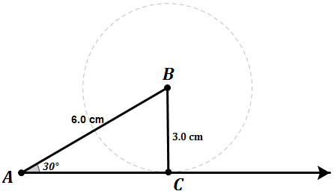
Case #3: (Two Triangles Possible)  Find the height of the triangle from point B to the ray emanating from point A.  $$AB∙sin\left(A\right)<BC<AB$$  $$6∙sin\left(33\right)<4<6$$  $$3.27<4<6$$ | 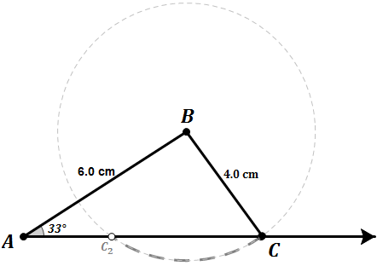
Case #4: (One Triangle Possible)  Find the height of the triangle from point B to the ray emanating from point A.  $$BC≥AB$$  $$6≥5$$ | 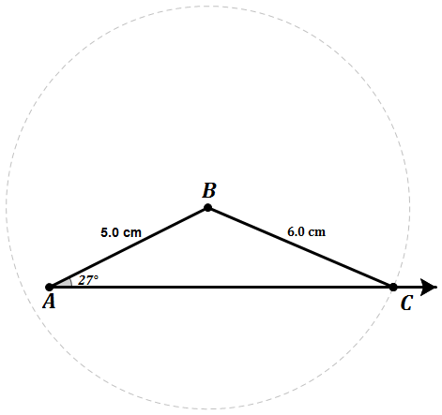
4. Sketch the potential triangle for each set of measures and determine which case of SSA is presented

- Triangle ∆ABC with measures $A=38°, c=8 , a=10$

- Triangle ∆MED with measures $M=40°, d=9 , m=6$

- Triangle ∆FUN with measures $F=32°, n=12 , f=8$

- Triangle ∆TRY with measures $T=45°, y=3\sqrt{2} , t=3$

- Triangle ∆LOG with measures $L=50°, g=30 , l=26$

- Triangle ∆HIP with measures $P=30°, p=6 , h=12$

M. Winking Unit 1-4 page 15
5. Consider ABC with the measures $A=25°, c=6 , a=3$. Determine all of the unknown sides of both triangles that could be created with those measures.
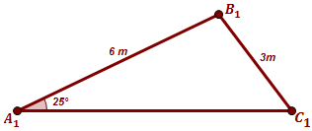
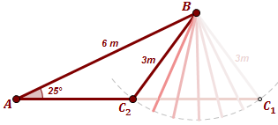
Standard Case
Ambiguous Case

C₂ ≈
B₂ ≈
b₂ ≈
C₁ ≈
B₁ ≈
b₁ ≈

5. Consider ABC with the measures $A=32°, c=7 , a=5$. Determine all of the unknown sides of both triangles that could be created with those measures.
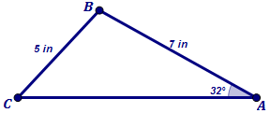
Sketch the Ambiguous Case
Standard Case

C₂ ≈
B₂ ≈
b₂ ≈
C₁ ≈
B₁ ≈
b₁ ≈

M. Winking Unit 1-4 page 16

