
Sec 3.3 – Basic Trigonometric Equations
Inverses of Trigonometric Functions Name:
x | y
$$-2π$$ | 0
$$\frac{-3π}{2}$$ | 1
$$-π$$ | 0
$$\frac{-π}{2}$$ | – 1
0 | 0
$$\frac{π}{2}$$ | 1
$$π$$ | 0
$$\frac{3π}{2}$$ | – 1
$$2π$$ | 0

Consider the graph of the function f(x) = sin(x) shown below.

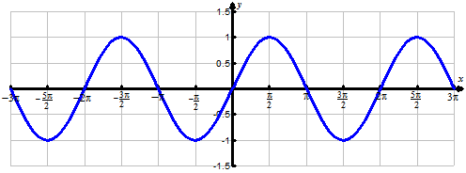

Using coordinate points of the graph to assist you and create a sketch of the inverse of f(x) = sin(x).

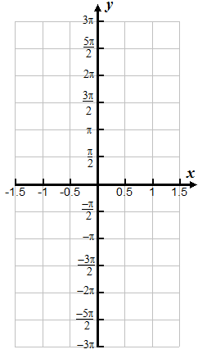
x | y

Explain whether or not the complete inverse of f(x) = sin(x) is a function.

Highlight or emphasize the part of the graph above known as f(x) = Sin⁻¹(x)

p.55

M. Winking (Section 3-3) ©

x | y
$$-2π$$ | 1
$$\frac{-3π}{2}$$ | 0
$$-π$$ | – 1
$$\frac{-π}{2}$$ | 0
0 | 1
$$\frac{π}{2}$$ | 0
$$π$$ | – 1
$$\frac{3π}{2}$$ | 0
$$2π$$ | 1

Consider the graph of the function f(x) = cos(x) shown below.

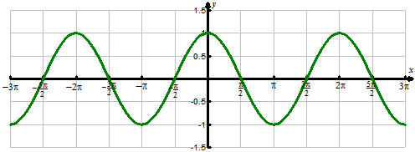

Using coordinate points of the graph to assist you and create a sketch of the inverse of f(x) = cos(x).

x | y

Explain whether or not the complete inverse of f(x) = cos(x) is a function.

Highlight or emphasize the part of the graph above known as f(x) = Cos⁻¹(x)

M. Winking (Section 3-3) ©

p.56

x | y
$$-2π$$ | 0
$$\frac{-3π}{2}$$ | Undefined
$$-π$$ | 0
$$\frac{-π}{2}$$ | Undefined
0 | 0
$$\frac{π}{2}$$ | Undefined
$$π$$ | 0
$$\frac{3π}{2}$$ | Undefined
$$2π$$ | 0

Consider the graph of the function f(x) = tan(x) shown below.

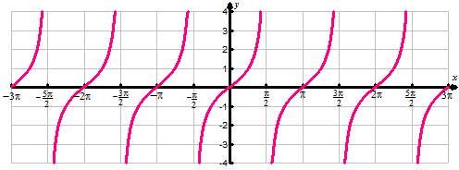

Using coordinate points of the graph to assist you and create a sketch of the inverse of f(x) = tan(x).

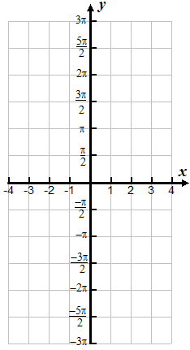
x | y

Explain whether or not the complete inverse of f(x) = tan(x) is a function.

Highlight or emphasize the part of the graph above known as f(x) = Tan⁻¹(x)

M. Winking (Section 3-3) ©

p.57

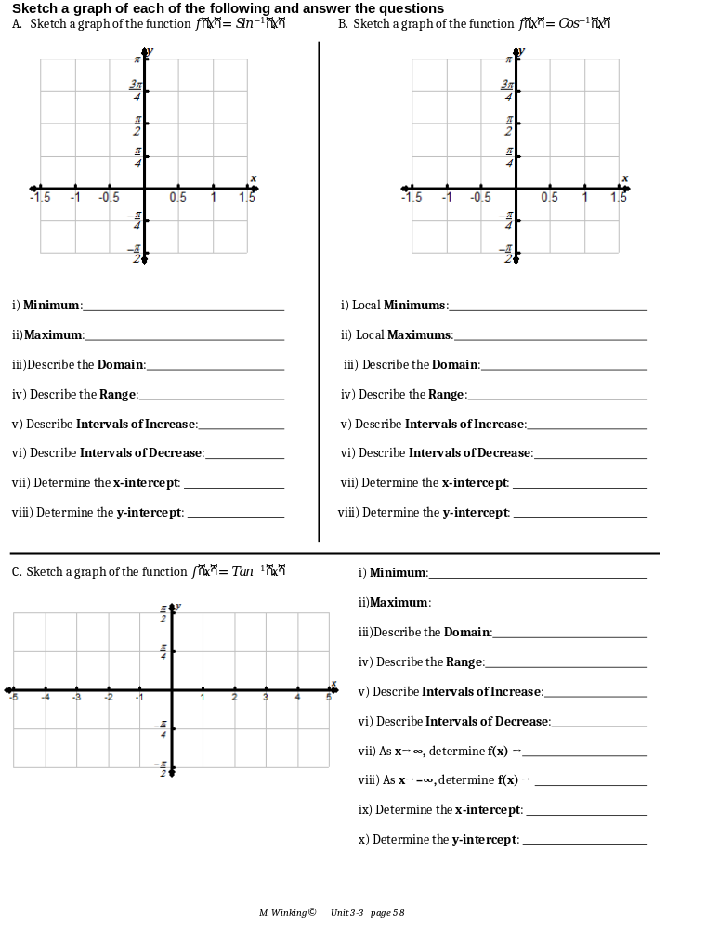
Using your knowledge of inverse trigonometry functions, determine the value of the following:
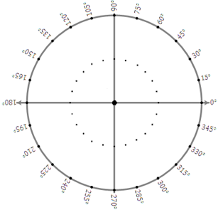
- ${Sin}^{-1}\left(sin\left(150°\right)\right)=$

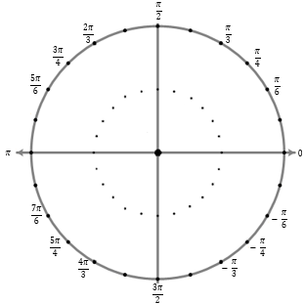
- ${Cos}^{-1}\left(cos\left(225°\right)\right)=$

- ${Sin}^{-1}\left(sin\left(\frac{4π}{3}\right)\right)=$

- ${Tan}^{-1}\left(tan\left(\frac{5π}{6}\right)\right)=$

M. Winking (Section 3-3) ©

p.59

