
Sec 4.5 – Trigonometric Identities
Trigonometric Equations & Applications Name:
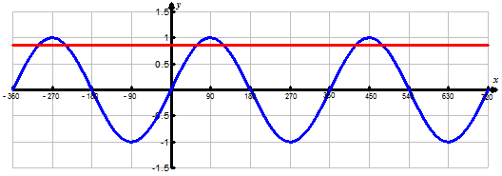
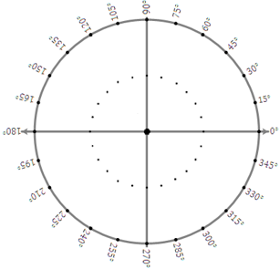
Find the general solution to the following in degrees using a roster solution and an algebraic solution.
$$y=\frac{\sqrt{3}}{2}$$
- $sin\left(x\right)=\frac{\sqrt{3}}{2}$

$$y=\sin{x}$$

Roster Solution:
Algebraic Solution:

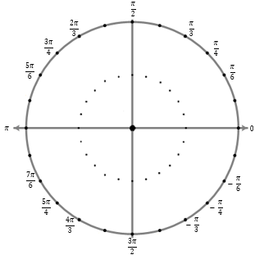
Find the general solution to the following in radians using a roster solution and an algebraic solution.
- $cos\left(x\right)=- \frac{\sqrt{2}}{2}$
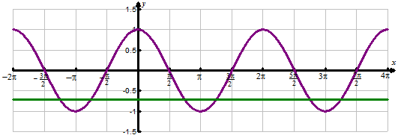
$$y=\cos{x}$$

$$y=-\frac{\sqrt{2}}{2}$$

Roster Solution:
Algebraic Solution:

M. Winking (Section 4-5) ©

p.72

Find the general solution to the following in degrees using a roster solution and an algebraic solution.
- $2cos\left(x\right)+ 4 =3$

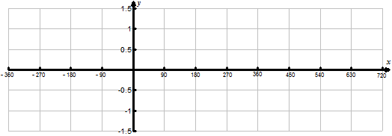

Roster Solution:
Algebraic Solution:

Find all solutions to the following problem in radians using a roster solution and an algebraic solution.
- $2sin\left(x\right)=-\sqrt{3}$

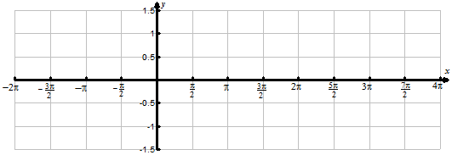

Roster Solution:
Algebraic Solution:

M. Winking (Section 4-5) ©

p.73

Find all solutions to the following problems in radians using a roster solution and an algebraic solution.
- $sin\left(2x\right)-sin\left(x\right)=0$

Roster Solution:
Algebraic Solution:

- $cos\left(2x\right)-cos\left(x\right)=0$

Roster Solution:
Algebraic Solution:

M. Winking (Section 4-5) ©

p.74

Using your graphing calculator solve the following.
- The average high temperature of a day in Atlanta can be modeled by the following equation:
$T=20sin\left(0.017\left(d+1.816\right)\right)+69$

Where ‘T’ represents the temperature in Fahrenheit and ‘d’ is the day number of year (e.g. Feb. 2nd would be day 33)

- Using the model, what is the average high temperature in Atlanta on February 12th?

- Using the model, what 2 dates should the average high temperature be 82° F?


- The height (in feet) above aground of a child in a swing can be given by the function with respect to time in seconds. (starting from the swings highest point)
$$h=3sin\left(\frac{2π}{3}\left(t+0.75\right)\right)+4$$

- Using the model, what is the height of the child after 2 seconds?

- Using the model, at what times is the height of the child 6 feet high?

p.75

M. Winking (Section 4-5) ©

