
- Sec 4.8 – Using Mathematical Models
2D/3D Geometric Models Name:
Choosing a Model

Prism | Pyramid | Cylinder | Cone | Sphere | Hemisphere
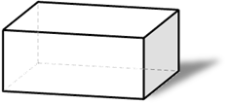 | 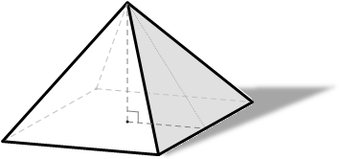 | 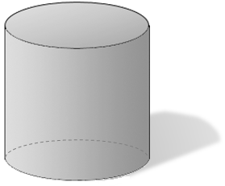 | 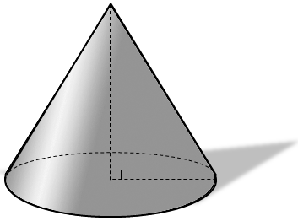 | 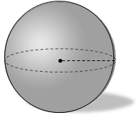 | 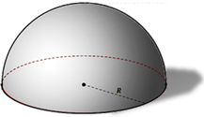
$$SA=2\left(lh+hw+lw\right)$$  $$V=l∙h∙w$$ | $$SA=LA+B$$  $$V=\frac{1}{3}l∙h∙w$$ | $$SA=2πrh+2πr^{2}$$  $$V=π∙r^{2}∙h$$ | $$SA=πrl+πr^{2}$$  $$V=\frac{1}{3}π∙r^{2}∙h$$ | $$SA=4πr^{2}$$  $$V=\frac{4}{3}π∙r^{3}$$ | $$SA=2πr^{2}$$  $$V=\frac{2}{3}π∙r^{3}$$

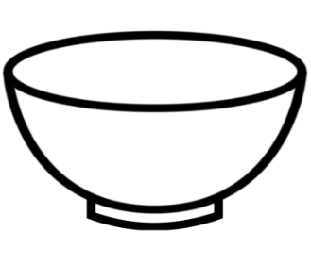
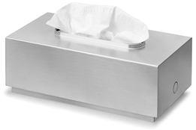
- Which geometric solid would be best to use as a model of the following objects found in the real world.

- B. c.

1a.
1b.
1c.

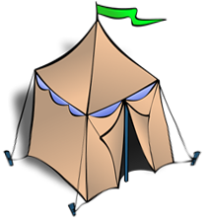
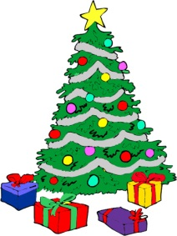
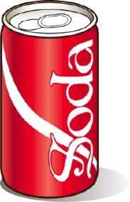
D. E. F.

1d.
1e.
1f.

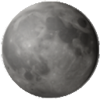
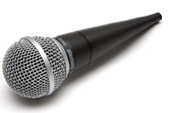
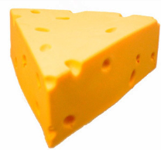
G. H. I.

1g.
1h.
1i.

M. Winking Unit 4-8 page 1

- Use geometric models of length and area to help you solve the following problems.
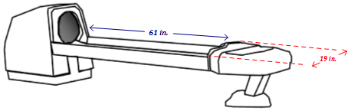
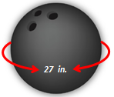
- The circumference of a standard bowling ball is 27 inches. A bowling alley uses a bowling ball return machine that will hold 2 rows of bowling balls. The tray to hold the bowling balls in the machine shown in the diagram has dimensions 19 in. in width by 61 in. in length. How many bowling balls can the tray hold?

2a.

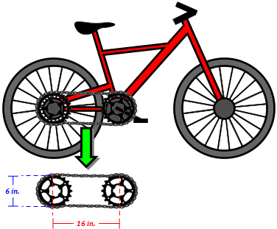
- A bicycle uses a chain to drive the rear wheel. The bike shown at the right uses two sprocket gears that are 6 inch in diameter connected by a chain. The chain could be described as a compound figure comprised of a rectangle and 2 semicircles and the length of the rectangle is 16 inches. How long is the chain?

2b.

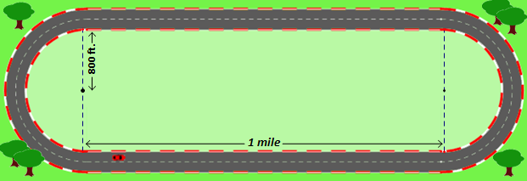
- Approximate the number of vehicles that could fit on the 2 lanes of the race track shown in the picture. Each vehicle needs approximately 18 feet of space.
(1 mile = 5280 feet)

2c.

M. Winking Unit 4-8 page 2

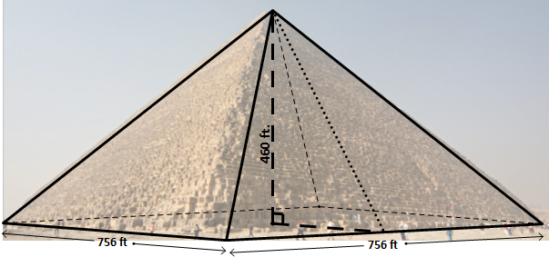
- Use geometric models of length and area to help you solve the following problems.
  - The largest of the Great Pyramids is the Pyramid of Giza. It is a square based pyramid. The square’s sides are 756 feet and the pyramid has a height of 460 feet. The pyramid was originally covered by lime stone. If a restoration team wanted to resurface the lateral faces with lime stone again which costs about $5 per square foot of area, how much would that amount of lime stone cost today to resurface the Great Pyramid of Giza.
(Hint: remember that we would only need to resurface the lateral faces)

3a.

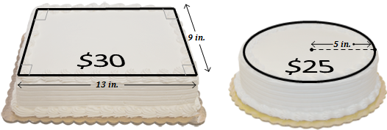
  - A bakery sells both of the cakes shown. The rectangular cake has the dimensions of 13 in. by 9 in which costs $30 and the circular cake has a radius of 5 in. which costs $25. If we assume the cakes are made with the same contents and the height of each cake is the same, which is the better deal? (i.e. which gives you more cake for the amount spent?)

3b.

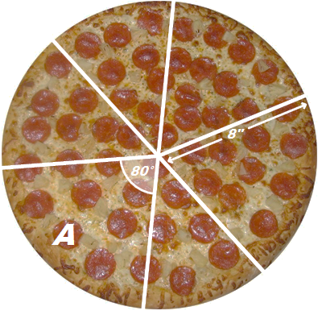
  - Jerry purchased a large pizza for a study group that cost $14. A friend, David, in the study group offered to pay for the pizza slice he was going to eat which was labeled “A” in the diagram. The pizza slice is a sector of the circle with a central angle of 80˚. How much should David give Jerry if he only wants to pay for the proportion of the pizza he ate?

3c.

M. Winking Unit 4-8 page 3

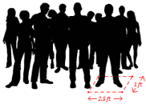
- Use geometric models of length and area to help you solve the following problems.
  - One rule of thumb for estimating crowds is that each person occupies 2.5 square feet. Use this rule to estimate the size of the crowd watching a concert in an area that is 150 feet long and 240 feet wide.
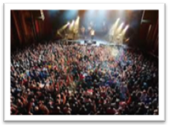

4a.


  - Jessie owns an apple tree orchard in North Georgia. He has approximately 3 trees for every 1400 square feet of land. Jesse has 940 apple trees on his property. The orchard requires exactly half of the land on Jesse’s farm. How many acres is Jesse’s farm? (1 acre = 43,560 square feet)
4b.

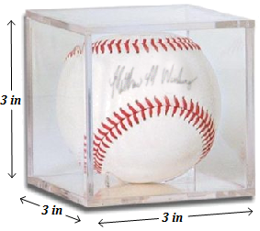
- Use geometric models of volume to help you solve the following problems.
  - An autographed based ball is encased in a plastic case. The owner would like to completely fill the rest of the container with an acrylic epoxy to completely preserve the baseball. The interior dimensions of the case are 3 in. by 3 in. by 3 in. The cube perfectly inscribes the ball. How many fluid ounces of acrylic will need to be poured in to fill the remaining space? (1 cubic inch = 0.554 fluid ounces)

5a.

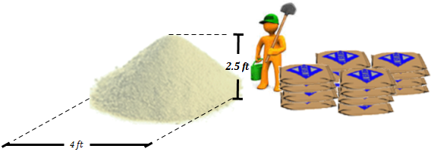
  - A grounds keeper for a golf course purchased a pile of sand dropped off by a truck for $70. The manager of the golf course also purchased 16 bags of sand for $70. Each bag contains 1 cubic foot of sand. Which was the better purchase?

5b.

M. Winking Unit 4-8 page 4

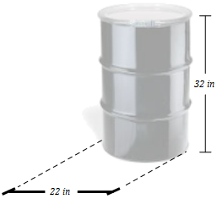
- Use geometric models of volume to help you solve the following problems.
  - At a remote base camp, gasoline is stored in the barrels like the one shown. How many gallons does each barrel hold? (1 gallon = 231 cubic inches)

6a.

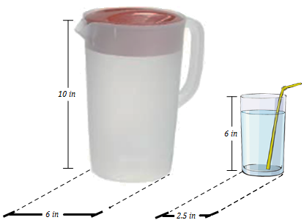
  - A water pitcher is 10 inches in height and 6 inches in diameter. Glasses used at a restaurant are 6 inches in height and 2.5 inches in diameter. If a server at the restaurant completely fills the pitcher with water, how many glasses of water can he completely fill without any ice?

6b.


  - Two types of ice cubes are designed for drinks. One is in the shape of a perfect cube and another is in the shape of a sphere. They both have the same volume of 27 cm³. Determine the surface area of each. The ice with the most surface area will melt the fastest because it has the most contact with the liquid that it is in. Which ice cube should melt the quickest?

6c.

M. Winking Unit 4-8 page 5

