
Sec 3.2 – Applications of Derivatives
Higher Derivatives and Concavity Name:
We know a general derivative of a function provides a description of the function’s slope (or rate of change). What if we considered finding the general derivative of a derivative of a function which would be the rate of change of the slope of a function.
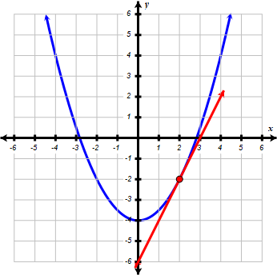
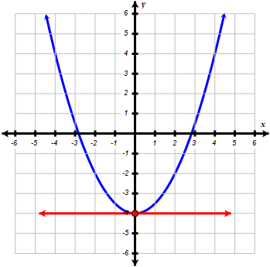
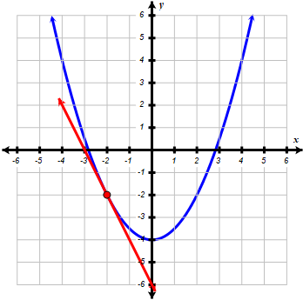
f (x)
f (x)
f (x)

m = 2
m = – 2

m = 0

Consider the function above $f\left(x\right)=\frac{1}{2}x^{2} - 4$ and the function’s derivative which would be $f'\left(x\right)=x$. As you can see, as x increases from left to right in the example graphs above we can see the slope m increases from – 2 to 0 to 2. Since the rate of the slope is increasing the derivative of the derivative must be positive over that range. The derivative of $f'\left(x\right)=x$ would be $f''\left(x\right)=1$. So when the second derivative of a continuous function over a range is positive, the function is concave up. Alternately, when the second derivative of a continuous function over a range is negative, the function is concave down.

The concept of higher derivatives can be applied to practical examples such as position and time. The change in position over a period of time can be described as the rate velocity (first derivative). The rate of change in velocity over a period of time can be described as the rate of acceleration (second derivative). So, acceleration is a rate of the rate of velocity (which is a rate also). The time it takes a car to go from 0 mph to 60 mph is an example of acceleration (usually in mph/s). The rate of change in acceleration over a period of time can be described as the rate of jerk (third derivative).

- Find $f''\left(x\right)$ of each of the following functions.

- $f\left(x\right)=3x^{4}-x^{2}+2x^{-1}$ b. $f\left(x\right)=e^{2x}+ln\left(x^{2}\right)$

- Find $\frac{d^{2}y}{dx^{2}}$ of each of the following functions.

- $y=x∙sin\left(2x\right)$ b. $y=\sqrt{2x+1}$

M. Winking © Unit 3-2 page 67

- Find $\frac{d^{2}y}{dx^{2}}$ of the relations .

- $x^{2}+y^{2}=9$ b. $\ln\left(xy\right)=2$

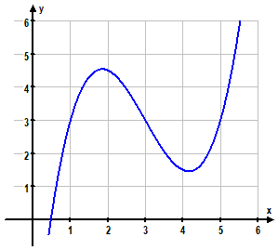
Inflection
Point
Concave
Down
Concave
Up

An inflection point of a function f(x) is defined as a point (c, f(c)) on a curve at which the sign of the curvature (concavity) changes. Specifically $f''\left(c\right)=0$ with $f''\left(c-ε\right)$ and $f''\left(c+ε\right)$ being different signs

- Determine any inflection points and describe the intervals on which the following functions are concave up or down
- $f\left(x\right)={2x}^{3}-3x^{2}-12x$ b. $g\left(x\right)=ln\left(x^{2}+1\right)$

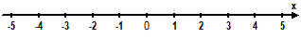
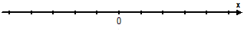

M. Winking © Unit 3-2 page 68

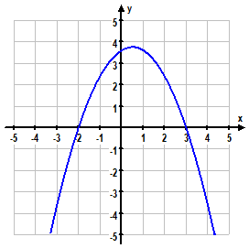
- Find any inflection points and describe the intervals on which the following functions are concave up or down.
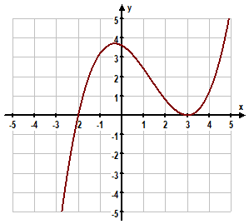
b.
a.

f “(x)
g”(x)

- Determine any inflection points and describe the intervals on which the following functions are concave up or down
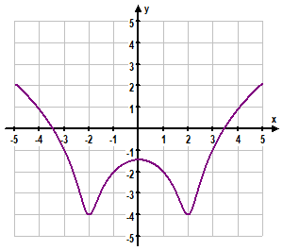
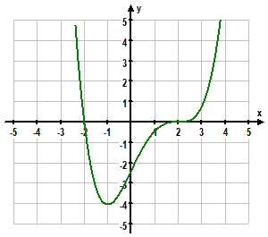
a.
b.
h’(x)

p‘(x)

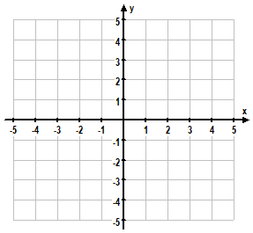

- Based on the table of values between which values of x must an inflection point lie given $a<b<c<d<e$
x | a | b | c | d | e
f ”(x) | – 2 | 3 | 0 | 1 | – 1

M. Winking © Unit 3-1 page 69

